

**Name –PRATHMESH PATIL**

**AIIT BCA SEM-III**

**A71004819033**

**WEB DESIGNING LAB**

|  |  |  |  |  |
| --- | --- | --- | --- | --- |
| **Sr.No** | **Practical Name** | **Date** | **Page no.** | **Remarks** |
| 1 | Create a basic html page | 05/08/2020 | 3 |  |
| 2 | To use Style tag on website | 19/08/2020 | 6 |  |
| 3 | Write a program to create a form | 26/08/2020 | 10 |  |
| 4 | Write a program to create a Responsive Webpage. | 02/09/2020 | 14 |  |
| 5 | Create a responsive layout of a webpage using flex that includes:  header  Horizontal navigation bar  3 left sidebars  1 main content  and 1 right sidebar that will display an image | 23/09/2020 | 18 |  |
| 6 | Create a responsive Layout using Grid that breaks at 800px and 550px. | 30/09/2020 | 23 |  |
| 7 | Create an Animation for your page using CSS Animation Property. | 07/10/2020 | 30 |  |
| 8 | 1. Create a calculator using Javascript.  2. Take input from user and check if number is prime or not using javascript | 28/10/2020 | 36 |  |
| 9 | 1.Write a program to explain all output methods of javascript.  2. Write a program to explain javascript pop-up boxes  3. Write a program explain queryselector and queryselectorAll by taking nesting of elements | 04/11/2020 | 44 |  |
| 10 | Write a program for form validation using regular expression for   1. Phone number 2. email 3. password | 18/11/2020 | 56 |  |
| 11 | Write an XML to show library books database.  2. Write an XSL code to display XML transformation to XSLT (take above XML of library. | 25/11/2020 | 60 |  |

**PRACTICAL NO:1**

**Aim:-** Simple Layout using HTML

**Code:-**

<html>

<head>

<title>Website</title>

</head>

<body>

<h2 title="Welcome to my first webpage">Information</h2>

<p><b>Hello !</b></p>

<p>Myself <u>Prathmesh Patil</u></p>

<p>I am studying <big>BCA</big> from AMITY Univeristy mumbai</big></p>

<p>My favourite Food is : <i>Chinese</i> </p>

<p>My hobby are :<br> <small>Reading</small>

<br> <code> listining music </code> <br>

<sub> </sub> </p>

<p>I like playing <big>Pubg</big> </p>

<h3>My education </h3>

<ol type = "A">

<li> I have done My 10 from <strong>Dy Patil</strong>

<ol type = "a">

<li>Maths</li>

<li>science</li>

<li>social studies </li>

<li>English </li>

<li>computer </li>

<li>hindi </li>

<li>Marathi</li>

<li>ICT</li>

</li>

</ol>

<li> I have done MY 12 from Dy Patil Jr College in <del>PCM</del>

<ul style="list-style: square;">

<li>physic</li>

<li>chemistry</li>

<li>maths</li>

<li>computer science </li>

<li>English </li>

</li>

</ul>

</body>

</html>

**Output:-**

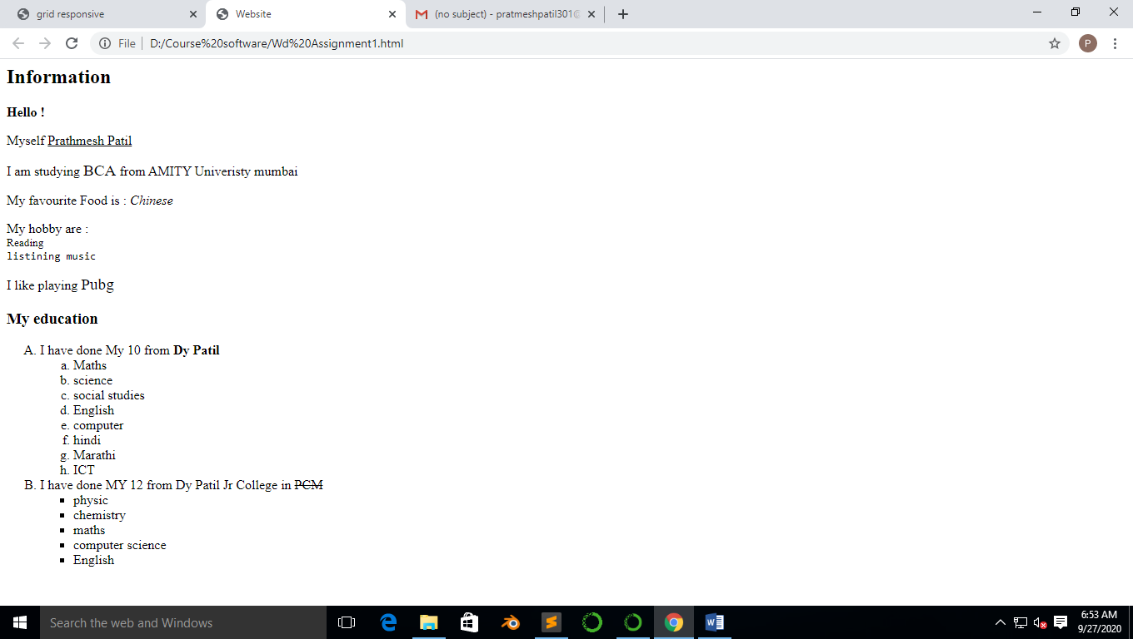

**PRACTICAL NO:2**

**Aim:** To use Style tag on website.

**Code:-**

<html>

<head>

<title>Website</title>

<style>

header{

background-color:yellow;

text-align:center;

padding:30px;

}

nav{

background-color:lightgreen;

width:200px;

height:500px;

padding:10px;

float:left;

}

section{

background-color:orange;

width: 700px;

text-align:justify;

padding: 20px;

float:left;

}

img{

width:650px;

height:400px;

}

footer{

background-color:darkgreen;

text-align:center;

font-size:40px;

padding:10px;

clear:both;

}

</style>

</head>

<body>

<header>

<h1>My first website</h1>

</header>

<nav>

<a href ="https://en.wikipedia.org/wiki/Groot#:~:text=Groot%20is%20an%20extraterrestrial%20tree,was%20destroyed%20in%20the%20battle.">CLICK HERE FOR MORE INFORMATION</a><br><br>

<a href ="https://student.amizone.net/">lOGIN</a><br><br>

<a href ="https://www.marvel.com/">ABOUT US</a><br><br>

</nav>

<section>

<p>Groot is a Flora colossus from Planet X, the capital of the branch worlds. The Flora colossi are tree-like beings whose language is almost impossible to understand due to the stiffness of their larynxes, causing their speech to sound like they are repeating the phrase "I am Groot". Other beings try to be friendly but become angry with the Flora colossi for not being able to speak. (Groot was shown to be capable of speaking not just understandably but eloquently throughout Annihilation: Conquest.) The Flora colossi are ruled over by the "Arbor Masters" and teach the children of the species with "Photonic Knowledge", which is the collected knowledge of the Arbor Masters of the generations and is absorbed through photosynthesis; this is a highly advanced education method, making the Flora colossi geniuses. Planet X's biome is managed by "Maintenance Mammals" which are small raccoon-like beings.[volume & issue needed]

The Flora colossus sapling that would come to be known as "Groot" came from an "Ennobled Sap-line" and was gifted with a tremendous grasp of quasi-dimensional super-positional engineering. Groot did not get along with fellow saplings but instead preferred the company of the "Maintenance Mammals", which the other saplings treated with prejudice. Groot was exiled by the "Arbor Masters" in Guardians of the Galaxy after killing another sapling to defend a maintenance mammal it was brutalizing.

An alternate origin was presented in the Groot ongoing series. In the story, it is revealed that the other Flora colossi had been abducting organisms from other planets, including a young human girl named Hannah. After seeing Hannah, Groot realized that what his people were doing was wrong, and managed to save the child and send her back to Earth. However, for his disobedience, Groot was exiled from Planet X and forced to wander the universe until he met Rocket Raccoon many decades later, where this version of Groot later became a member of the Guardians of the Galaxy.

Yet another alternate origin was presented in "Guardians of Infinity", written by Edgardo Miranda Rodriguez, wherein a woman makes the claim that Groot is a ceiba tree from Ponce, Puerto Rico. According to Puerto Rican folklore, a ceiba tree is believed to possess the spirits of the indigenous Taino population that formerly thrived on the Caribbean island. By her logic, the woman considers Groot to be Puerto Rican.</p>

</section>

<section>

<img src="img/wp3913855.jpg"></section>

<footer>copyright</footer>

</body>

</html>

**Output:-**

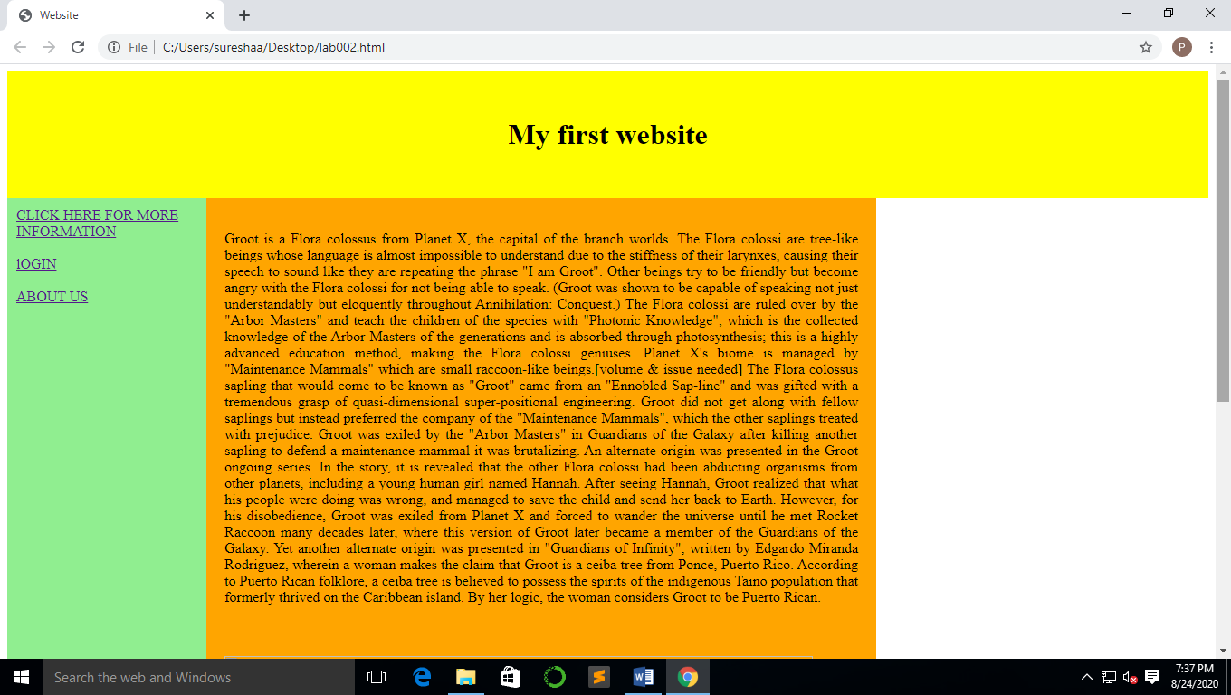

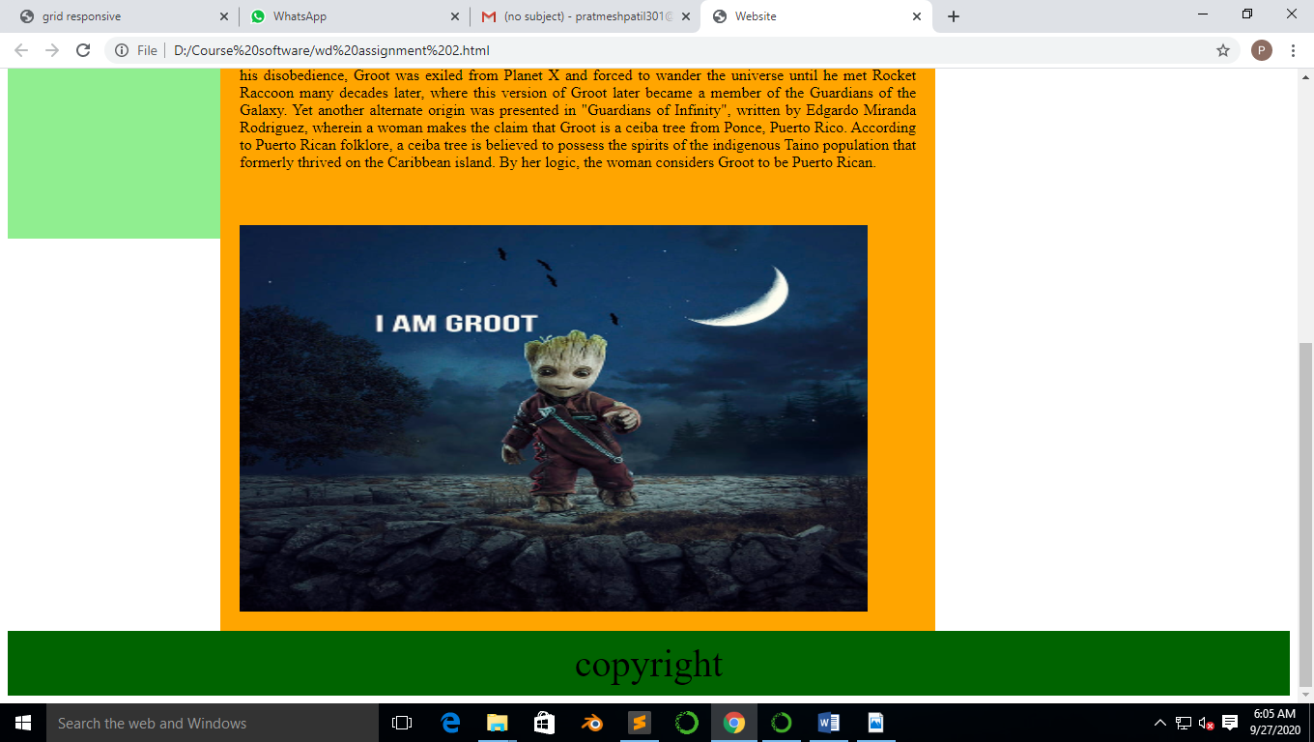

**PRACTICAL NO:3**

**Aim:-** To create a form.

**Code:-**

<html>

<head>

<title>Registration Form</title>

</head>

<style>

body{

background-color:lightblue;

text-align:left;

}

h1{

background-color:orange;

text-align:left;

font-size:15px;

color:white;

padding:15px;

margin:auto;

width:670px;

}

form{

margin:auto;

padding:50px;

width:600px;

text-align:left;

background-color:black;

color: gold;

}

input{

position: auto;

padding:auto;

font-size:auto;

text-align:auto;

left:100px;

}

input[type="text"]

{

top:50px;

left:50px;

right:50px;

bottom:50px;

display: block;

margin-bottom: auto;

width: 50%;

border:2px solid black;

}

input[type="password"]

{

display: block;

margin-bottom: auto;

width: 50%;

border:2px solid black;

}

input[type="number"]

{

display: block;

margin-bottom: auto;

width: 50%;

border:2px solid black;

}

input[type="email"]

{

display: block;

margin-bottom: auto;

width: 50%;

border:2px solid black;

}

input[type="month"]

{

display: block;

margin-bottom: auto;

width: 50%;

border:2px solid black;

}

input[type="country"]

{

display: block;

margin-bottom: auto;

width: 50%;

border:2px solid black;

}

input[type="Gender"]

{

display: block;

margin-bottom: auto;

width: 50%;

border:2px solid black;

}

label{

position:default;

right: 100px;

padding: 5px;

}

</style>

<body>

<h1>sign up</h1>

<form>

<label for="first name">First Name:</label>

<input type="text" placeholder="first name">

<label for="last name">Last Name:</label>

<input type="text" placeholder="last name">

<label for="surname name">Surname Name:</label>

<input type="text" placeholder="Surname Name">

<label for="Month">Date of Birth:</label>

<input type="month" placeholder="Month">

<label for="date">Date</label>

<input type="number" id="date" name="date">

<div>

<lable for="Gender:">Gender:</lable>

<input type="radio" id="male" name="Gender">

<lable for="male">male</lable>

<input type="radio" id="female" name="Gender">

<lable for="male">female</lable>

</div>

<label for="USA">Country:</label>

<input type="country" placeholder="USA">

<label for="E-mail">E-mail:</label>

<input type="email" placeholder="E-mail">

<label for="Enter phone number">Phone NO:</label>

<input type="number" placeholder="Enter phone number">

<label for="Enter your password">Password:</label>

<input type="password" placeholder="Enter your password">

<label for="confirm your password">Confirm password:</label>

<input type="password" placeholder="confirm your password">

<div>

<input type="radio" id="I agree to the terms of use">

<lable for="I agree to the terms of use">I agree to the terms of use</lable>

</div>

</form>

</body>

</html>

**Output:-**

Before filling-up form:-

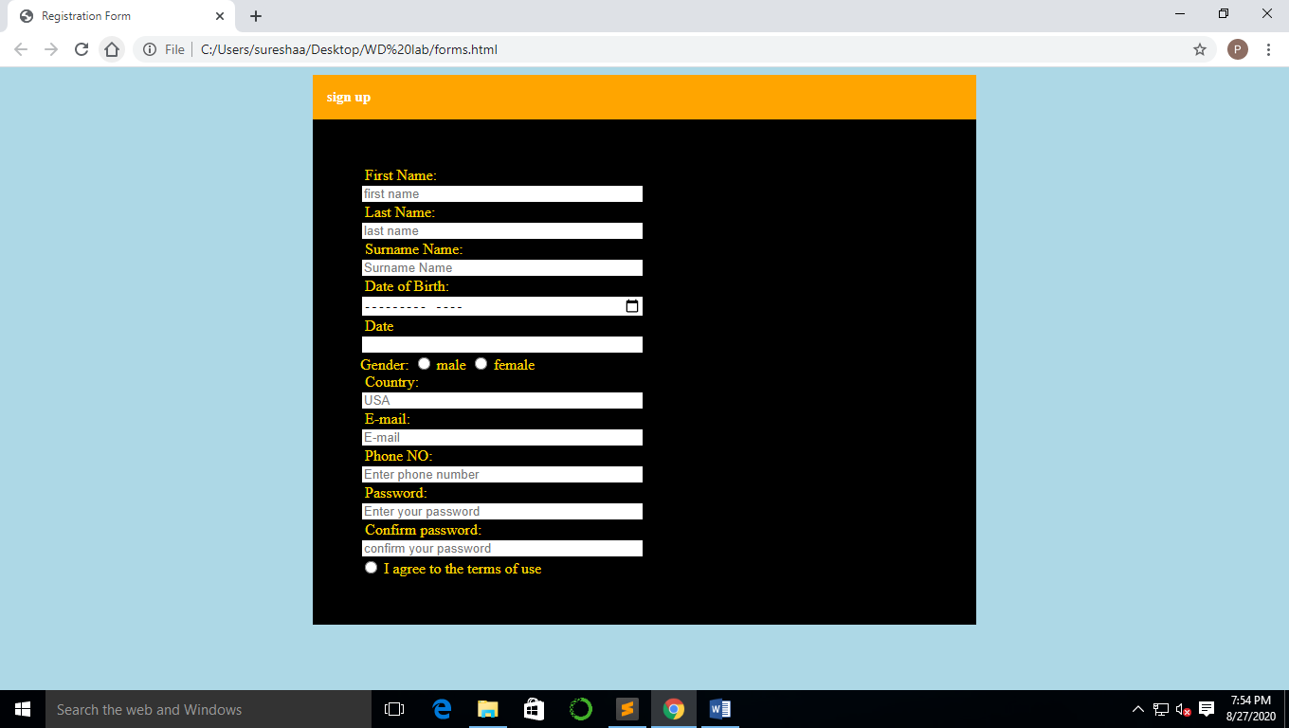

After filling-up form:-

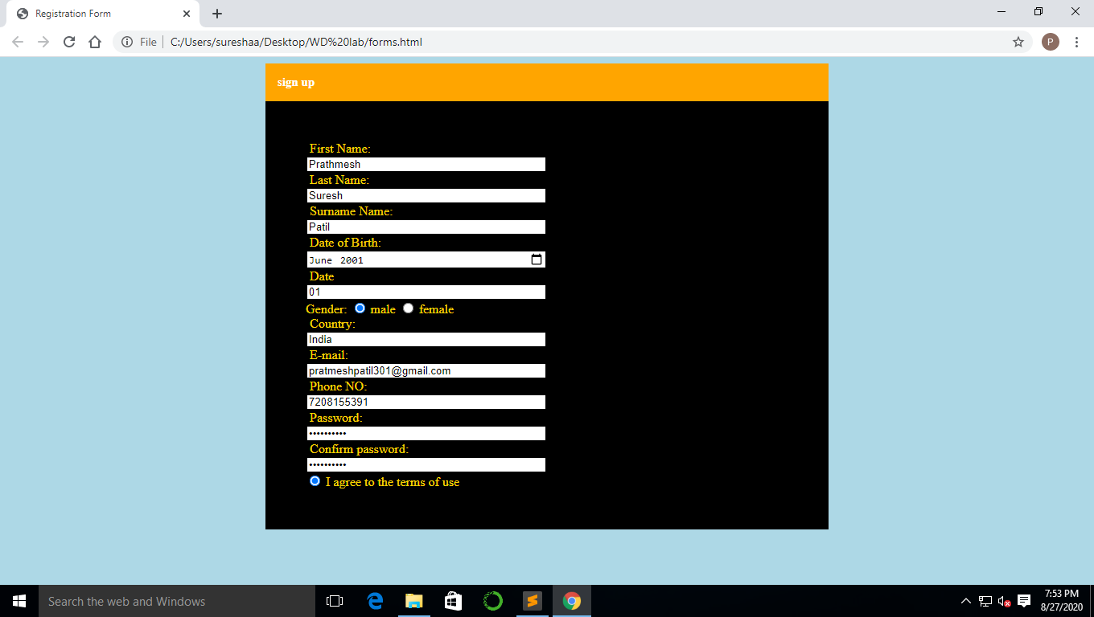

**Practical NO:4**

**Aim:-** Write a program to create a Responsive Webpage.

**Code:-**

<html>

<head>

<meta name="viewport" content="width=device-width,intial scale=1.0">

<tilte>Responsive website</tilte>

</head>

<style>

*{box-sizing:border-box;}

header

{

background-color: limegreen;

padding: 15px;

text-align: center;

background-image:

}

.b1{

float:left;

width:20%;

}

.b1 a{

background-color: lightblue;

padding: 15px;

width: 100%;

display: block;

margin-top: 6px;

}

section{

width:60%;

background-color: orange;

float: left;

padding:10px;

height:50%;

}

.right{

background-color: lightblue;

float:right;

width: 20%;

padding: 10px;

margin-top: 6px;

}

.left{

background-color: lightblue;

float:left;

width: 20%;

padding: 10px;

margin-top: 6px;

}

@media(max-width: 620px)

{

.b1,section,.right{width:100%;}

}

</style>

<body>

<header>

<h1>Operating system</h1></header>

<div>

<div class="b1">

<nav>

<a href="">Link 1</a>

<a href="">Link 2</a>

<a href="">about us</a>

</nav>

</div>

<p>

<section>

An Operating system (OS) is a software which acts as an interface between the end user and computer hardware. Every computer must have at least one OS to run other programs. An application like Chrome, MS Word, Games, etc needs some environment in which it will run and perform its task. The OS helps you to communicate with the computer without knowing how to speak the computer's language. It is not possible for the user to use any computer or mobile device without having an operating system.

</section>

</p>

<aside class="right">

<h2>What is kernel</h2>

<p>The kernel is the central component of a computer operating systems. The only job performed by the kernel is to the manage the communication between the software and the hardware. A Kernel is at the nucleus of a computer. It makes the communication between the hardware and software possible. While the Kernel is the innermost part of an operating system, a shell is the outermost one.</p>

<h3>Features of kernel</h3>

<p><ol>Low-level scheduling of processes</ol>

<ol>Inter-process communication</ol>

<ol>Process synchronization</ol>

<ol>Context switching</ol></p>

</aside>

</div>

</body>

</html>

**Output:-**

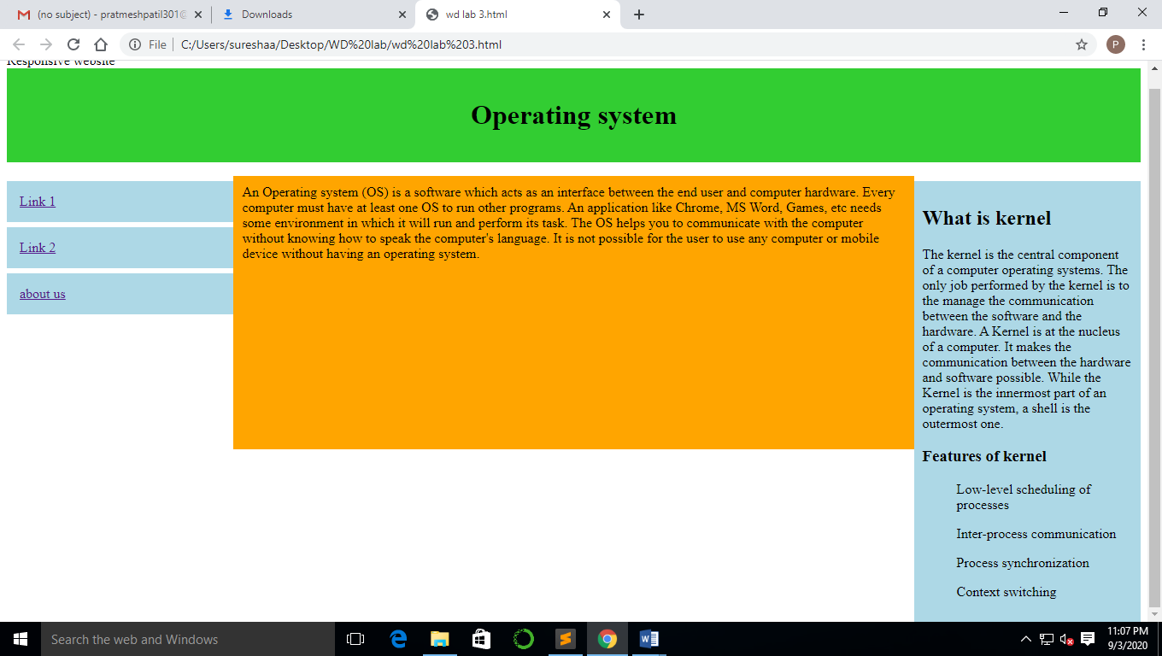

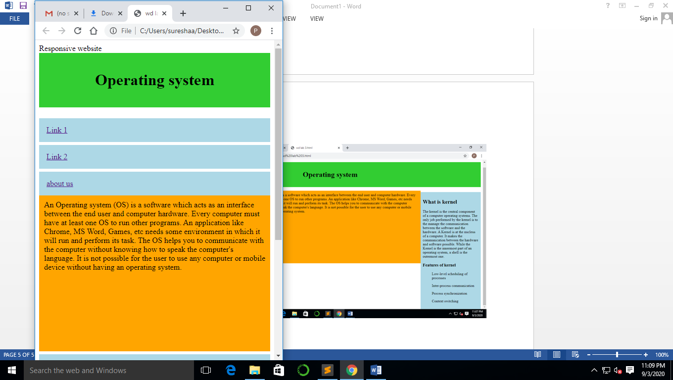

**PRACTICAL NO:5**

**Aim:-** Create a responsive layout of a webpage using flex that includes:

header

Horizontal navigation bar

3 left sidebars

1 main content

and 1 right sidebar that will display an image

**Code:-**

<!doctype html>

<title>Lab assignment</title>

<style>

* {

box-sizing: border-box;

}

body

{

display: flex;

min-height: 100vh;

flex-direction: column;

margin: 0;

}

#main {

display: flex;

flex: 1;

}

#main > article {

flex: 1;

}

#main > nav,

#main > aside {

flex: 0 0 20vw;

}

#main > nav {

order: -1;

}

nav{

text-align-last: left;

text-decoration-style: uderline;

float:left;

font-family: Times New Roman;

background-color: yellow;

font-size: 30px;

color: black;

}

aside{

background-color: red;

}

article{

font-family: Comic Sans MS;

background-color: steelblue;

}

header{

background:orange;

height: 20vh;

}

footer {

background:blue;

height: 20vh;

}

header, footer, article, nav, aside {

padding: 1em;

}

@media screen and (max-width: 575px) {

#main {

flex-direction: column;

}

footer

{

text-align: center;

font-family: Curlz MT;

font-size: 50px;

}

}

}

</style>

<body>

<header>

<h1 style="text-align:center;">AVENGERS</h1></header>

<div id="main">

<article>

<P><i>The Avengers are a fictional team of superheroes appearing in American comic books published by Marvel Comics. The team made its debut in The Avengers #1 (cover-dated Sept. 1963), created by writer-editor Stan Lee and artist/co-plotter Jack Kirby. The Avengers is Lee and Kirby's renovation of a previous superhero team, All-Winners Squad, who appeared in comic books series published by Marvel Comics' predecessor Timely Comics.

Labeled "Earth's Mightiest Heroes", the Avengers originally consisted of Iron Man, the Wasp, the Hulk, Thor, and Ant-Man. The original Captain America was discovered trapped in ice in issue #4, and joined the group after they revived him. A rotating roster became a hallmark of the series, although one theme remained consistent: the Avengers fight "the foes no single superhero can withstand." The team, famous for its battle cry of "Avengers Assemble!", has featured humans, superhumans, mutants, Inhumans, deities, androids, aliens, legendary beings, and even former villains.

The Avengers have appeared in a wide variety of media outside of comic books, including several different animated television series and direct-to-video films. The Avengers also play a central role in the Marvel Cinematic Universe (MCU) being the focus in multiple MCU feature films, beginning with the eponymous 2012 live-action film, The Avengers, and followed by the sequels Age of Ultron (2015), Infinity War (2018), and Endgame (2019), the latter two of which were based on The Infinity Gauntlet storyline.

</i></P>

</article>

<nav>

<a href="">SIGN IN</a>

<a href="">ABOUT US</a>

<a href="">CONTACT US</a>

</nav>

<aside><img src="C:\Users\SURESHA\Downloads\Avengers_Endgame_poster.jpg"

style = "width: 350px;height: 500px;"> </aside>

</div>

<footer>

<p style="text-align:center; "><i>"!!!!!!AVENGERS ASSEMBLE!!!!!!"</i></p>

</footer>

</body>

**Output:-**

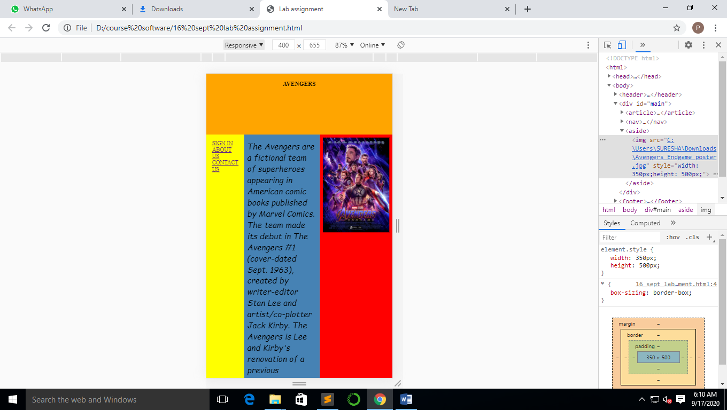

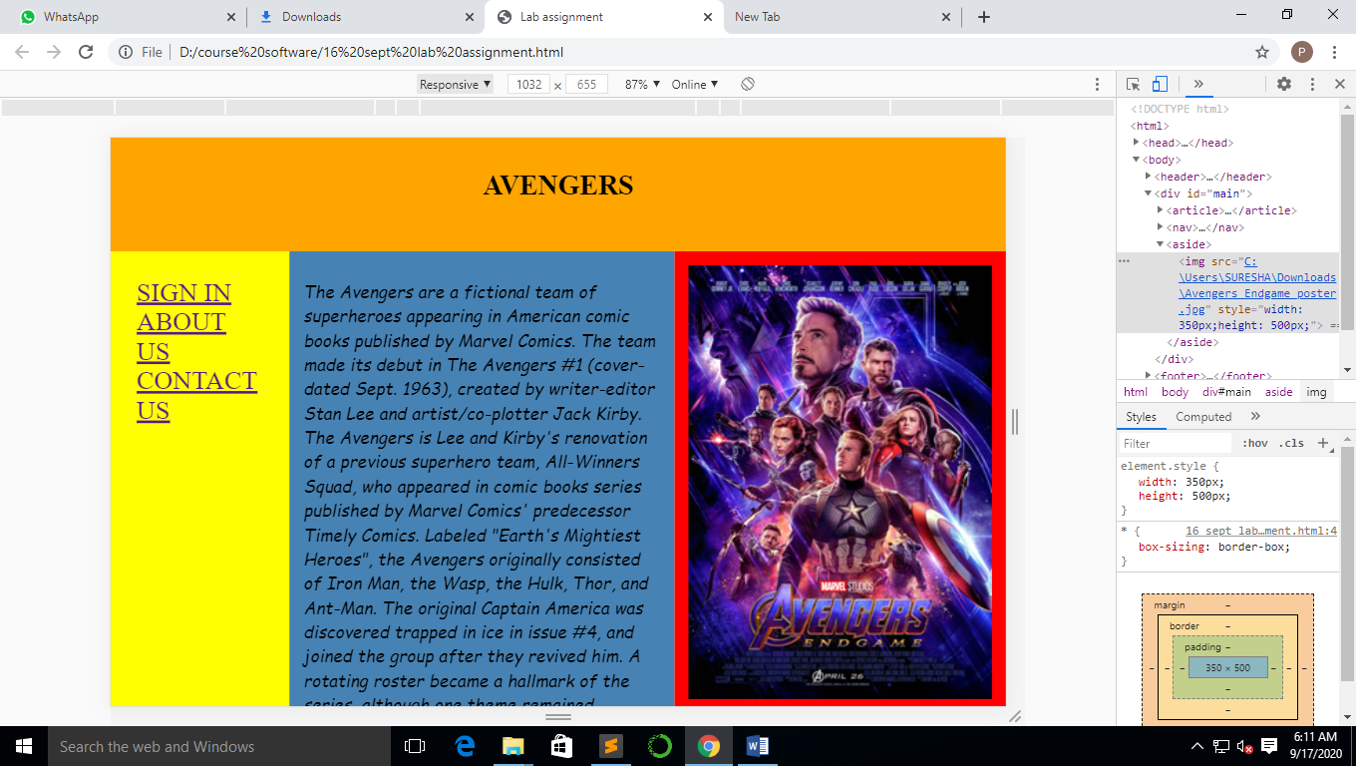

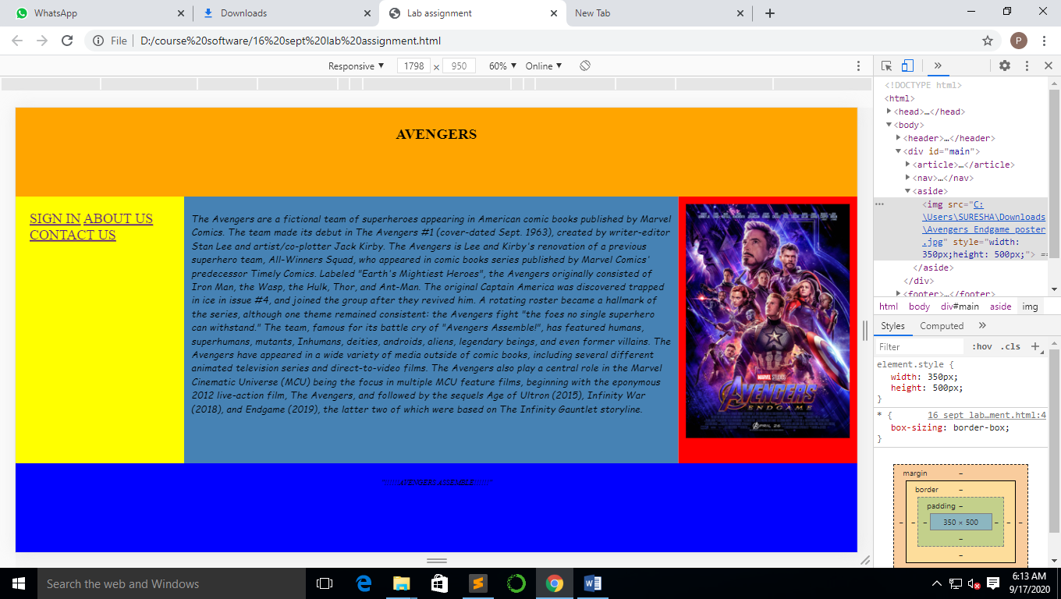

**PRACTICAL NO:6**

**Aim:-** Create a responsive Layout using Grid that breaks at 800px and 550px.

**Code:-**

<!DOCTYPE html>

<html lang="en">

<head>

<meta charset="UTF-8">

<meta name="viewport" content="width=device-width, initial-scale=1.0">

<title>grid responsive</title>

<style>

body{margin:10px;background-color:#7605f7; padding:0;}

#container{display:grid;height:200vh;background-color:#02f2b2;margin:5px;

grid-template-columns: 1fr 1fr 1fr 1fr;grid-gap: 1px;

grid-template-rows: .5fr 1.2fr 1fr .4fr;grid-gap: 6px;

grid-template-areas:

"nav nav nav nav"

"sidebar main main main"

"sidebar content1 content1 content2"

}

#container >div{border:5px solid black;}

#navigation{grid-column:1/5;grid-row:1/2;background-color: steelblue;}

#sidebar{grid-column:1/2;grid-row: 2/5;background-color: cyan;}

#main{grid-column: 2/5;grid-row:2/3;background-color: #f7cb05;}

#comtent1{grid-column: 2/4;grid-row:3/4;background-color:#b6f705 ;}

#content2{grid-area:3/4/4/5;background-color:#b6f705;}

#foot{grid-row:4/5;grid-column:2/5;background-color:#05c7f7;text-align: center;}

header{background-color: yellow;padding:5px;text-align: center;border:2px solid black;}

#nav{background-color:orange;height: 125px;border:2px solid black;}

#nav ol{text-align:left;margin:0;}

#nav ol li{display: inline-block;padding: 20px;margin-left:20px;}

#nav ol li a{color:green;padding: 7px;background-color:white;border-radius: 5px;}

#nav ol li a:hover{background-color: lime;text-decoration: none;}

.left{}

@media(max-width:550px)

{

#container{grid-template-columns: 1fr;grid-template-rows: .5fr .8fr 1fr .8fr .5fr .4fr; }

#navigation{grid-column: 1/2;grid-row:1/2;background-color:steelblue;}

#sidebar{grid-column: 1/2;grid-row:2/3;background-color:cyan;}

#main{grid-column: 1/2;grid-row: 3/4;background-color: #f7cb05;margin:10px;}

#content1{grid-column: 1/2;grid-row:4/5;background-color:#b6f705 ;}

#content2{grid-column: 1/2;grid-row: 5/6;background-color:#b6f705 ;}

#foot{grid-row: 6/7;grid-column: 1/2;background-color: #05c7f7;text-align: center;}

}

@media(min-width:800px)

{

#container{grid-template-columns: 1fr;grid-template-rows: .5fr .8fr 1fr .8fr .5fr .4fr; }

#navigation{grid-column: 1/2;grid-row:1/2;background-color:steelblue;}

#sidebar{grid-column: 1/2;grid-row:2/3;background-color:cyan;}

#main{grid-column: 1/2;grid-row: 3/4;background-color: #f7cb05;margin:10px;}

#content1{grid-column: 1/2;grid-row:4/5;background-color:#b6f705 ;}

#content2{grid-column: 1/2;grid-row: 5/6;background-color:#b6f705 ;}

#foot{grid-row: 6/7;grid-column: 1/2;background-color: #05c7f7;text-align: center;}

}

</style>

</head>

<body>

<div id="container">

<div id="navigation">

<header><h1>Lorem Ipsum</h1></header>

<div id="nav">

<ol>

<li><a href="">home</a></li>

<li><a href="#">About us</a></li>

<li><a href="#">Shop</a></li>

</ol>

</div>

</div>

<div id="sidebar"><h2>Languages</h2>

<ol>

<li>CHINESE</li>

<li>SPANISH

<li>ENGLISH</li>

<li>HINDI</li>

<li>ARABIC</li>

<li>PORTUGUESE</li>

<li>BENGALI</li>

<li>RUSSIAN</li>

</ol>

</div>

<div id="main"><h3>What is Lorem Ipsum?</h3>

<p>Lorem Ipsum is simply dummy text of the printing and typesetting industry. Lorem Ipsum has been the industry's standard dummy text ever since the 1500s, when an unknown printer took a galley of type and scrambled it to make a type specimen book. It has survived not only five centuries, but also the leap into electronic typesetting, remaining essentially unchanged. It was popularised in the 1960s with the release of Letraset sheets containing Lorem Ipsum passages, and more recently with desktop publishing software like Aldus PageMaker including versions of Lorem Ipsum.

</p>

</div>

<div id="content1"><h4>Why do we use it?</h4>

<p>It is a long established fact that a reader will be distracted by the readable content of a page when looking at its layout. The point of using Lorem Ipsum is that it has a more-or-less normal distribution of letters, as opposed to using 'Content here, content here', making it look like readable English. Many desktop publishing packages and web page editors now use Lorem Ipsum as their default model text, and a search for 'lorem ipsum' will uncover many web sites still in their infancy. Various versions have evolved over the years, sometimes by accident, sometimes on purpose (injected humour and the like).</p>

</div>

<div id="comtent2"><h5>Where can I get some?</h5>

<p>There are many variations of passages of Lorem Ipsum available, but the majority have suffered alteration in some form, by injected humour, or randomised words which don't look even slightly believable. If you are going to use a passage of Lorem Ipsum, you need to be sure there isn't anything embarrassing hidden in the middle of text. All the Lorem Ipsum generators on the Internet tend to repeat predefined chunks as necessary, making this the first true generator on the Internet. It uses a dictionary of over 200 Latin words, combined with a handful of model sentence structures, to generate Lorem Ipsum which looks reasonable. The generated Lorem Ipsum is therefore always free from repetition, injected humour, or non-characteristic words etc.

</div>

<div id="foot">"There is no one who loves pain itself, who seeks after it and wants to have it, simply because it is pain..."</div>

</div>

</body>

</html>

**Output:-**

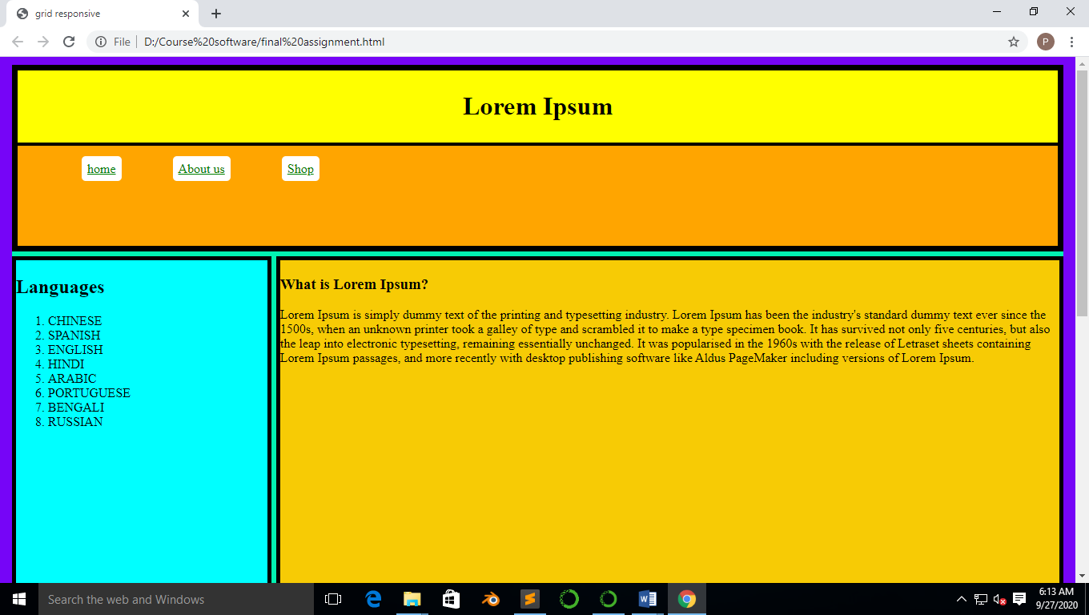

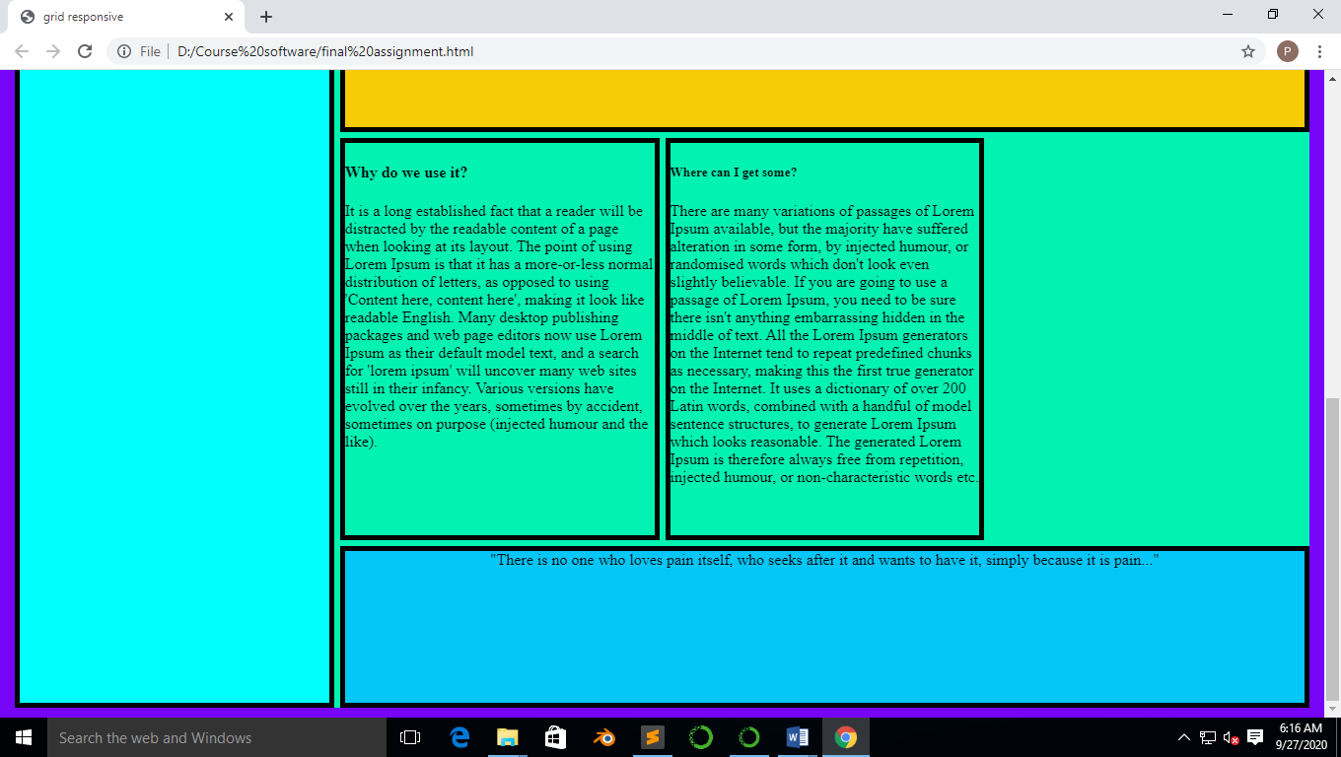

Responsive:-

at width 550px

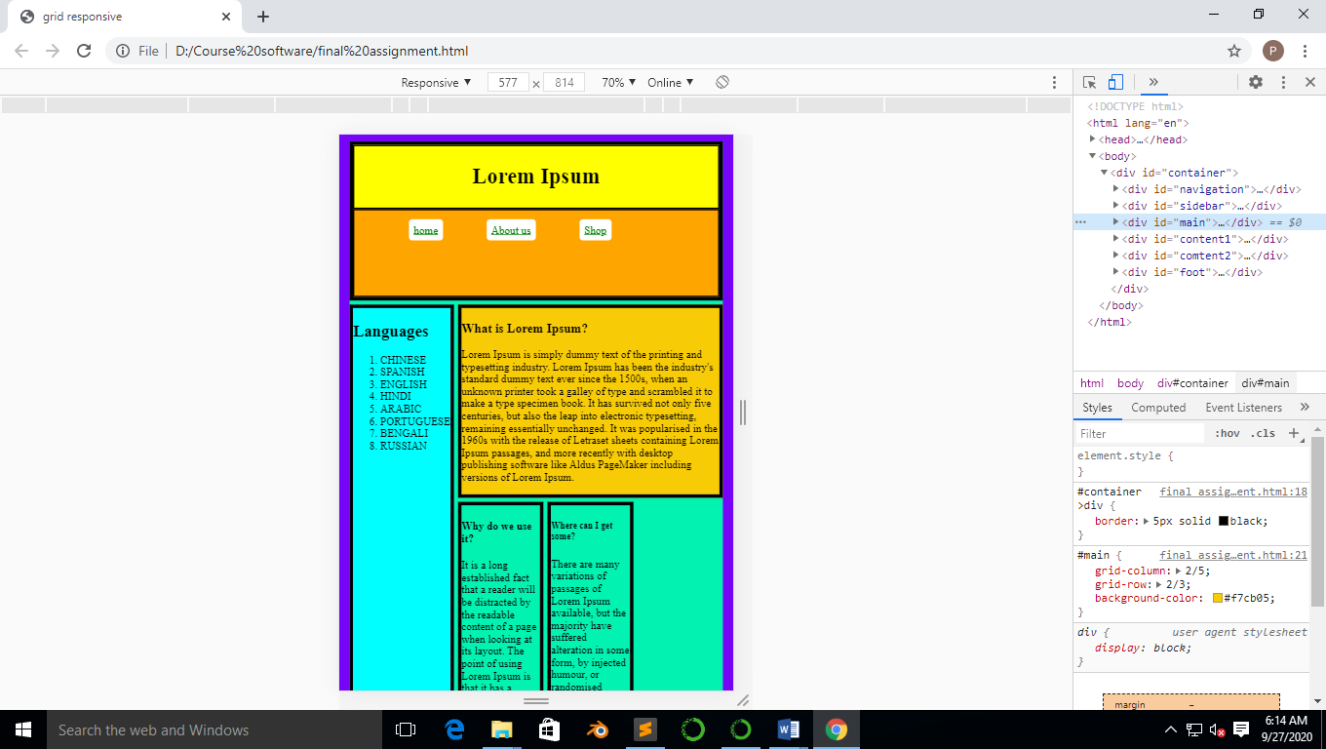

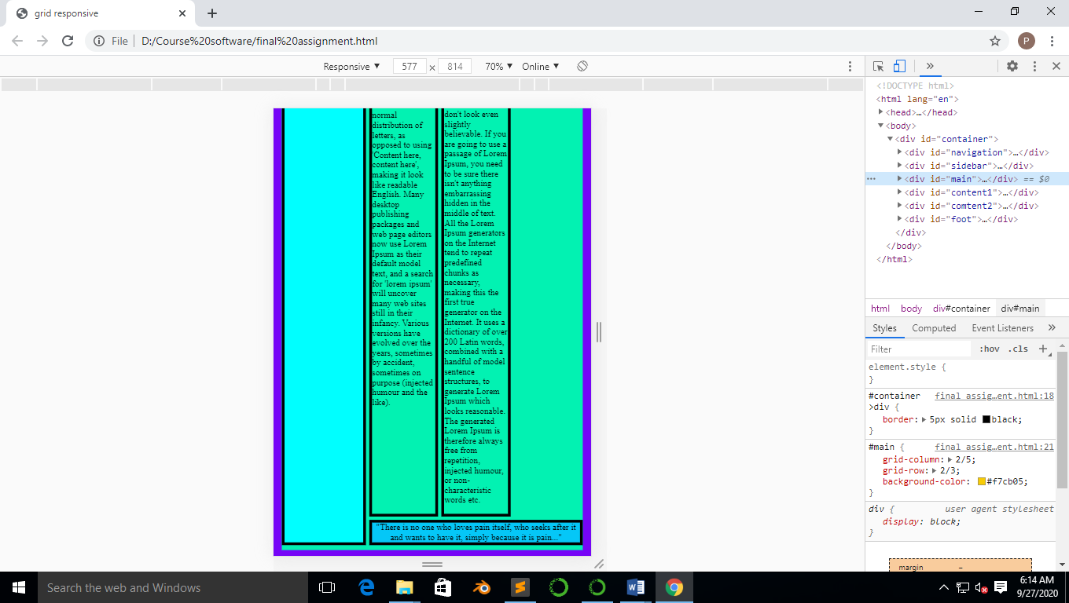

At width 800px

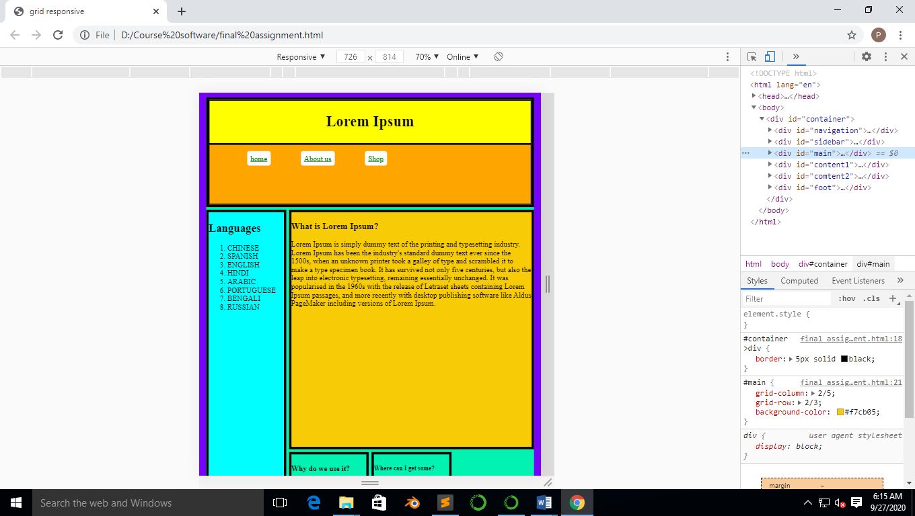

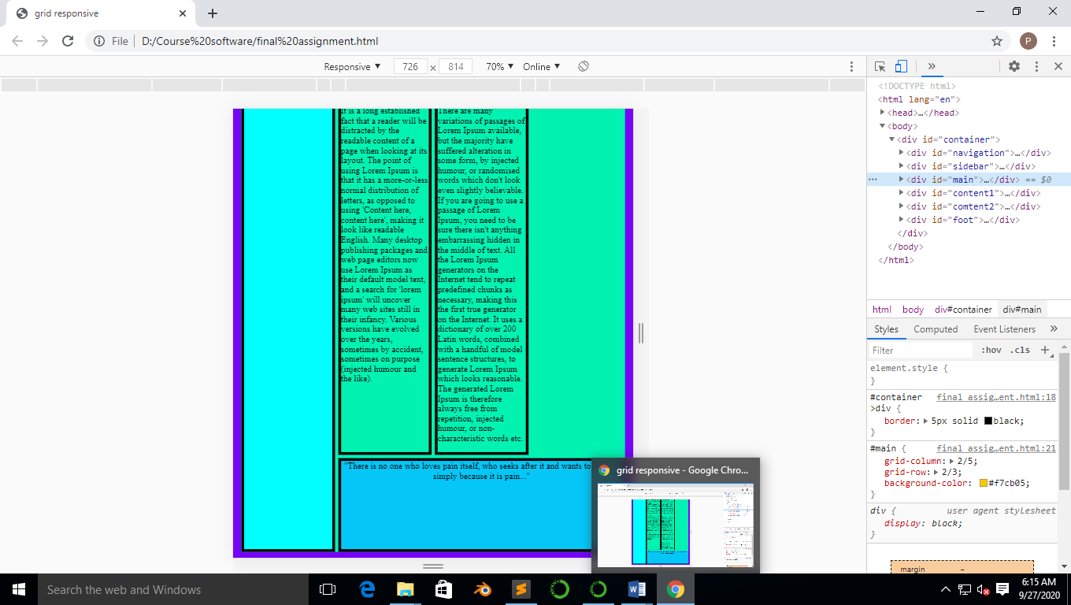

**PRACTICAL NO :-7**

Aim:- Create an Animation for your page using CSS Animation Property.

Code:-

<!DOCTYPE html>

<html>

<head>

<title>transparent nav</title>

<style>

body{

background-image:url(https://www.pxwall.com/wp-content/uploads/2018/07/Wallpaper%20Lines,%20digital,%20red,%204K,%20Abstract%20461651997.jpg);

background-repeat: no-repeat;

background-size: 100% 100%;

background-attachment: fixed;

}

ul{margin:0;padding:0;}

ul li{

width:200px;

height:40px;

background-color:#ed5377;

font-family: Colonna MT;

text-align:center;

font-size:20px;

float:left;

margin-right:7px;

list-style:none;

line-height:40px;

}

ul li a{text-decoration: none;color: black;display: block;}

ul li ul li{display: none;}

ul li:hover ul li{min-width: 100%;display: block;position: left;z-index: 999;}

@media screen and (max-width:600px;){

ul{position: relative;}

ul li{ float:none; display: block; text-align: center; }

ul li a{ float:none; display: block; text-align: center;}

ul li ul li{float:none; display: block; text-align: center;}

ul li:hover ul li{ float:none; display:block; text-align: center; }

}

</style>

</head>

<body>

<div>

<ul>

<li><a href="#">Home</a></li>

<li><a href="#">About</a>

<ul>

<li><a href="">Facebook</a></li>

<li><a href="">Instagram</a></li>

<li><a href="">Others</a></li>

</ul>

</li>

<li><a href="">Contact us</a></li>

<li><a href="">News</a></li>

<Li><a href="">Help</a></Li>

</ul>

</div>

</body>

</html>

Output:-

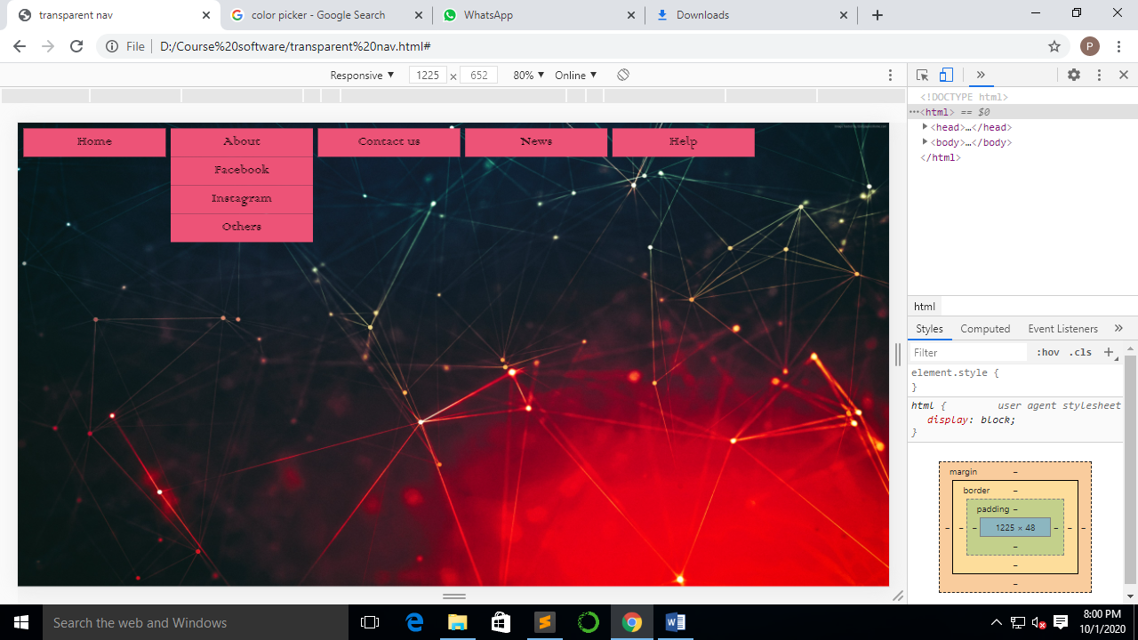

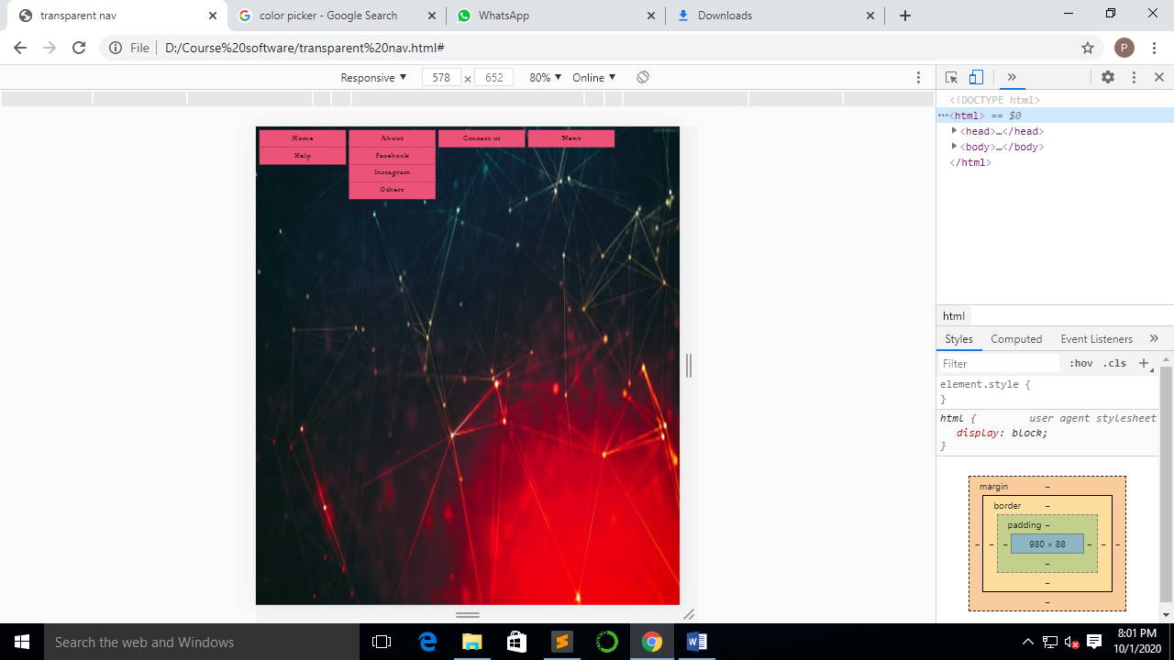

Code:-

<!DOCTYPE html>

<html>

<head>

<title>transparent animation nav</title>

<style>

body{

background-image:url(https://www.pxwall.com/wp-content/uploads/2018/07/Wallpaper%20Lines,%20digital,%20red,%204K,%20Abstract%20461651997.jpg);

background-repeat: no-repeat;

background-size: 100% 100%;

background-attachment: fixed;

}

ul{margin:0;padding:0;}

ul li{

width:200px;

height:40px;

background-color:#ed5377;

font-family: Colonna MT;

text-align:center;

font-size:20px;

float:left;

margin-right:7px;

list-style:none;

line-height:40px;

}

ul li a{text-decoration: none;color: black;display: block;animation:btn 1s infinite forwards;}

ul li ul li{display: none;}

ul li:hover ul li{min-width: 100%;display: block;position: left;z-index: 999;animation: btn 1s;}

@keyframes btn{

0%{transform:scale(1);}

100%{transform:scale(1.3);background-color: lime;}

}

#object{position: relative;border-radius: 100px;left:80%;width: 150px;height: 150px;font-family: Colonna MT;font-style: italic;background-color: red;

animation: anim1 3s linear infinite;z-index: 1;}

@keyframes anim1{

0%{transform: translate(0px,0);transform: scale(0.5);background-color: red;}

50%{ transform: translate(150px,0px); background-color: yellow }

100%{transform: translate(0,0);transform: scale(1.2);background-color: cyan;}

}

}

</style>

</head>

<body>

<div>

<ul>

<li><a href="#">Home</a></li>

<li><a href="#">About</a>

<ul>

<li><a href="">Facebook</a></li>

<li><a href="">Instagram</a></li>

<li><a href="">Others</a></li>

</ul>

</li>

<li><a href="">Contact us</a></li>

<li><a href="">News</a></li>

<Li><a href="">Help</a></Li>

</ul>

<div id="object">

<p><center>My first animation webpage</center><p>

</div>

</div>

</body>

</html>

Output:-

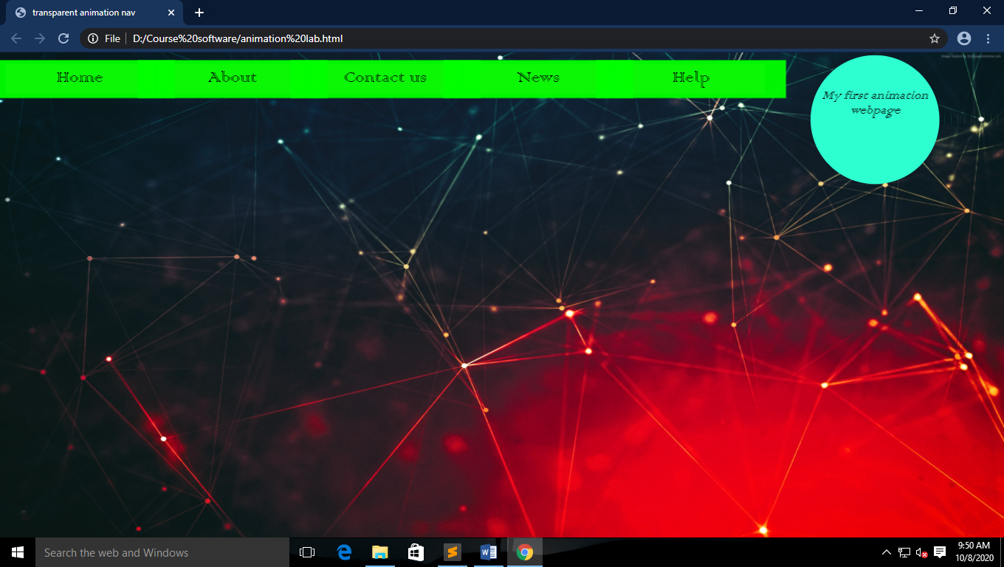

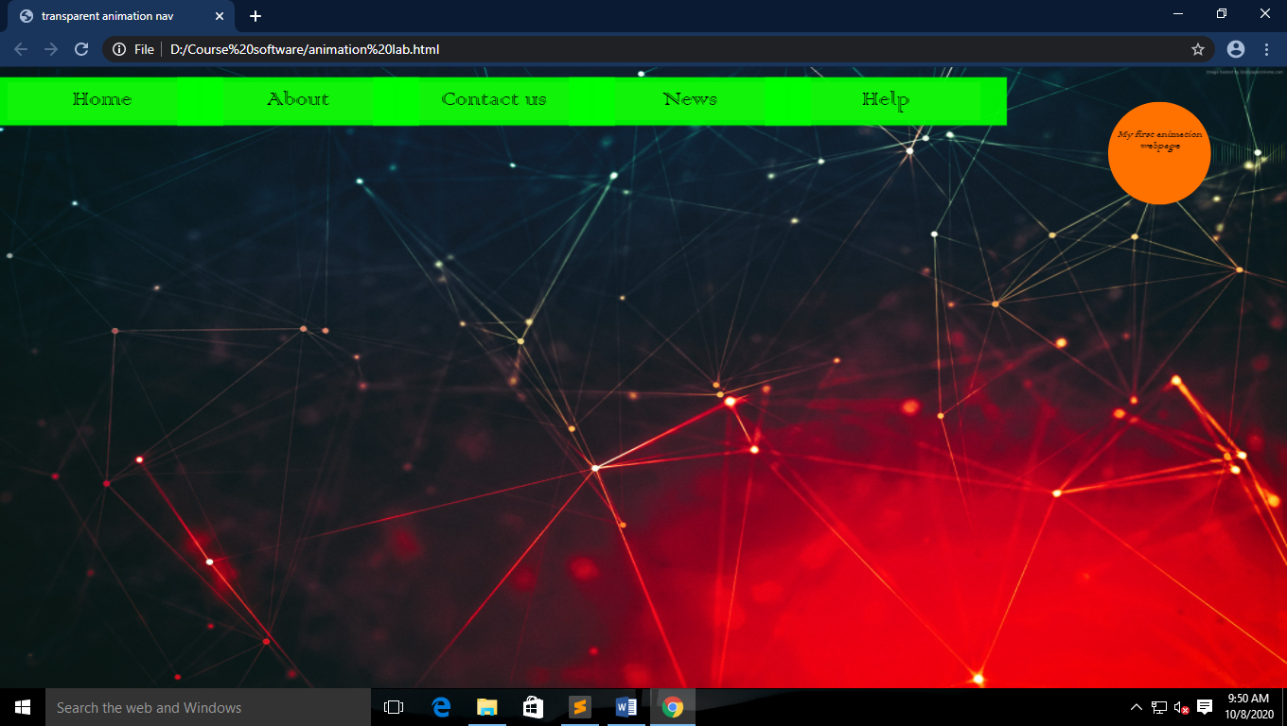

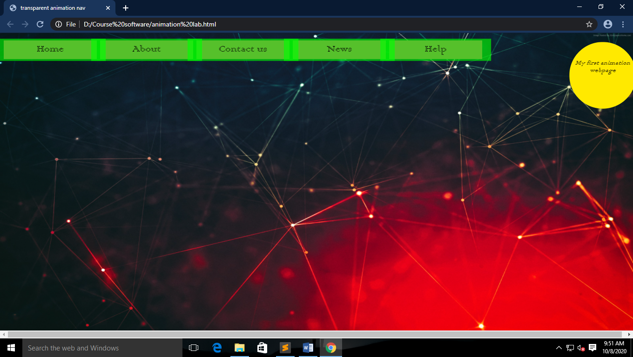

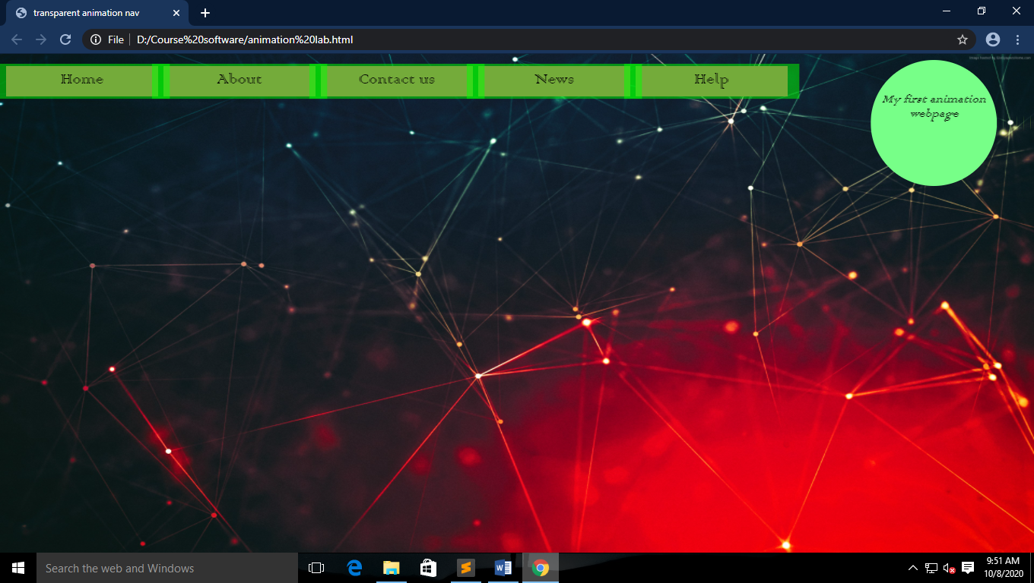

**PRACTICAL NO:-8**

Q1.Create a calculator using javascript.

Code:-

<!DOCTYPE html>

<html>

<meta charset="UTF-8">

<meta name="viewport" content="width=device-width, initial-scale=1.0">

<title>calculator</title>

<head>

<style>

body{

background-color: #def9ff;

}

#container{

background-color: orange;

border:5px solid black;

border-radius: 20px;

margin: 5px;

padding: 10px;

float: left;

position: absolute;

top: 50%;

left: 50%;

transform: translateX(-50%)translateY(-50%);

}

.button{

background-color: #c5ffa3;

width: 40px;

height:40px;

}

.button:hover{

background-color: black;

color: lime;

}

</style>

</head>

<body class="back">

<div id="container">

<div class="main">

<form name="form">

<input class="textview" name="textview" style="border:2px solid black;height: 30px; width: 200px; font-family: Unispace;font-size: 190%;">

</form>

<table>

<tr>

<td><input class="button" type="button" value="C" onclick="clean()"></td>

<td><input class="button" type="button" value="<" onclick="back()"></td>

<td><input class="button" type="button" value="/" onclick="insert('/')"></td>

<td><input class="button" type="button" value="*" onclick="insert('*')"></td>

</tr>

<tr>

<td><input class="button" type="button" value="1" onclick="insert(1)"></td>

<td><input class="button" type="button" value="2" onclick="insert(2)"></td>

<td><input class="button" type="button" value="3" onclick="insert(3)"></td>

<td><input class="button" type="button" value="+" onclick="insert('+')"></td>

</tr>

<tr>

<td><input class="button" type="button" value="4" onclick="insert(4)"></td>

<td><input class="button" type="button" value="5" onclick="insert(5)"></td>

<td><input class="button" type="button" value="6" onclick="insert(6)"></td>

<td><input class="button" type="button" value="-" onclick="insert('-')"></td>

<tr>

<td><input class="button" type="button" value="7" onclick="insert(7)"></td>

<td><input class="button" type="button" value="8" onclick="insert(8)"></td>

<td><input class="button" type="button" value="9" onclick="insert(9)"></td>

<td rowspan=5><input class="button" style="height:95px" type="button" value="=" onclick="equal()"></td>

</tr>

<tr>

<td colspan=2><input class="button" style="width:106px;" type="button" value="0" onclick="insert(0)"></td>

<td><input class="button" type="button" value="." onclick="insert('.')"></td>

</tr>

</table>

</div>

</div>

<script>

function insert(num) {

document.form.textview.value = document.form.textview.value + num

}

function equal() {

var exp = document.form.textview.value;

if (exp) {

document.form.textview.value = eval(document.form.textview.value)

}

}

function clean() {

document.form.textview.value = "";

}

function back() {

var exp = document.form.textview.value;

document.form.textview.value = exp.substring(0, exp.length - 1);

}

</script>

</body>

</html>

Output:-

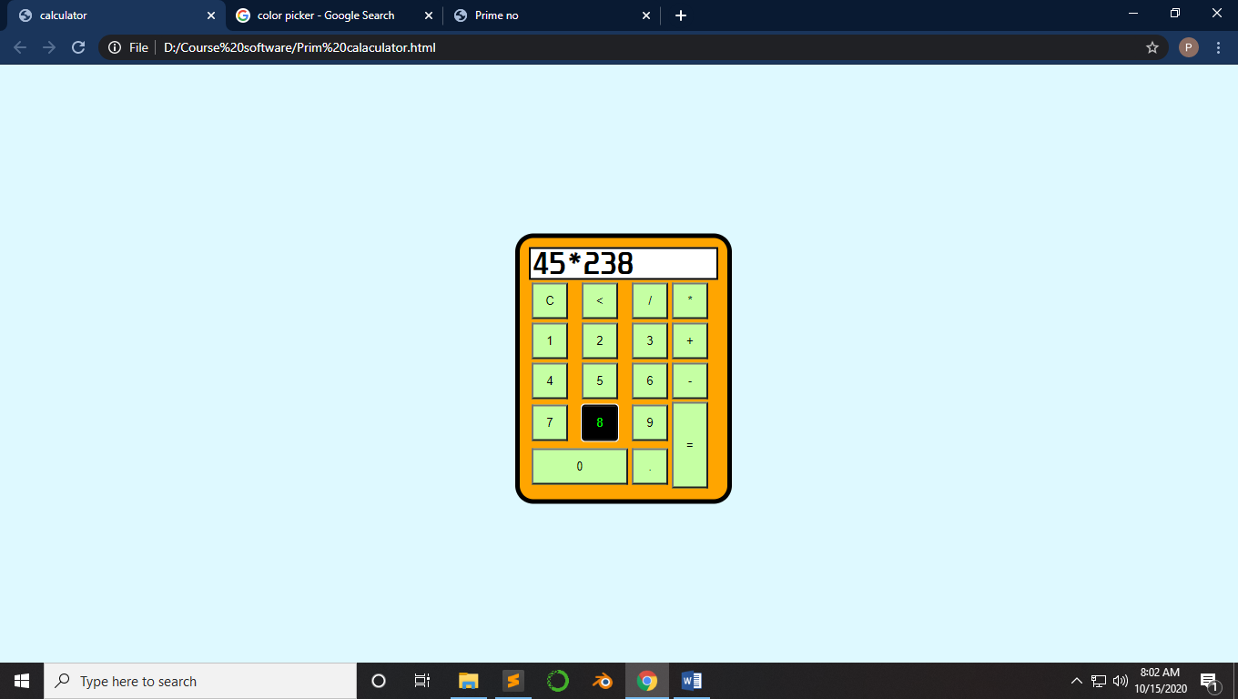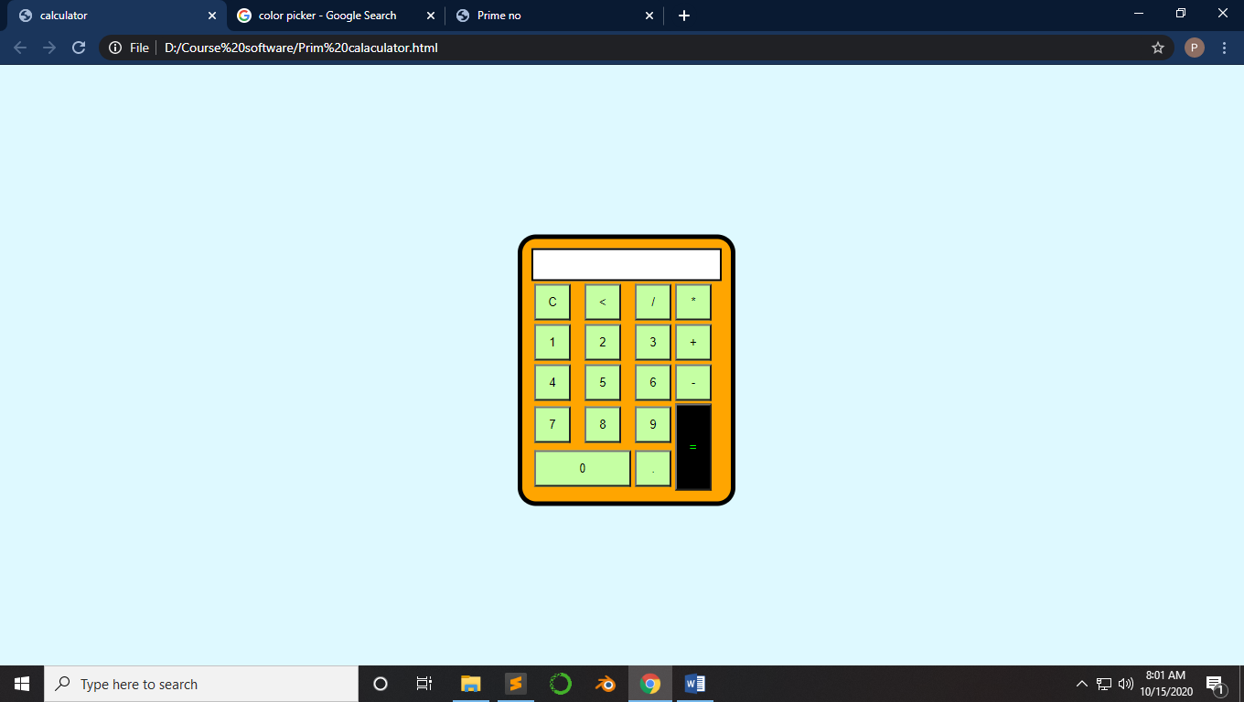

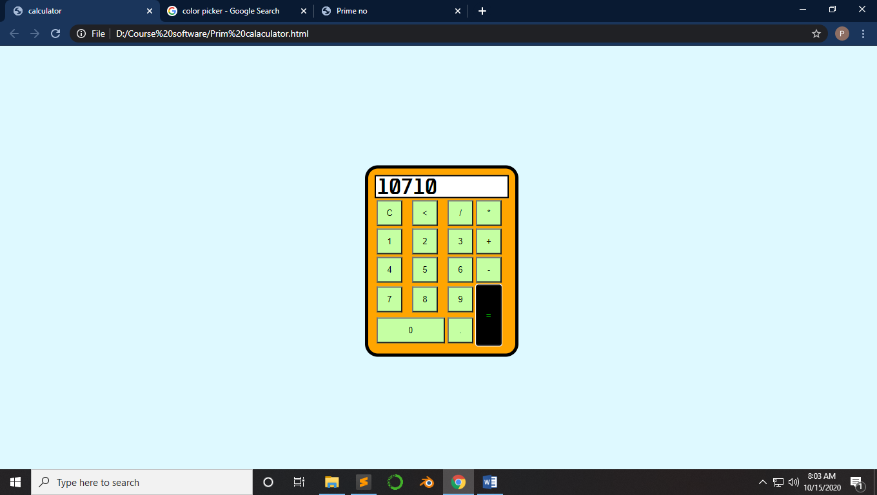

Q2.Take input from user and check if number is prime or not using javascript.

Code:-

<!DOCTYPE html>

<html lnag="en">

<head>

<meta charset="UTF-8">

<meta name="viewport" content="width=device-width, initial-scale=1.0">

<title>Prime no</title>

</head>

<style>

body{

background-color: orange;

}

h1{

position: absolute;

left: 40%;

font-family:Verdana;

}

#container{

background-color: lightblue;

font-family: Lucida Console;

border:5px solid black;

border-radius: 20px;

height: 40%;

margin: 5px;

padding: 10px;

float: left;

position: absolute;

top: 50%;

left: 50%;

transform: translateX(-50%)translateY(-50%);

}

</style>

<body>

<h1>Prime number checker</h1>

<div id="container">

<div id="text-section">

<p id="text-user">Enter the number to check it is prime number or not</p>

<input type="text" id="check">

</div>

<div id="number-section">

<p id="n-value"></p>

</div>

<div id="output-sec">

<p id="output-section"></p>

</div>

<div id="output-sec1">

<button type="button" onclick="prime();">Result</button></div>

<p id="output-section1"></p>

</div>

<script type="text/javascript">

function prime()

{

var num=document.getElementById("check").value;

var temp;

document.getElementById("n-value").innerHTML ="You Entered \: " + num;

for(var i=2; i<num; i++)

{

if(num%1==0)

{

temp = 1;

break;

}

}

if(temp == 1)

{

document.getElementById("output-section").innerHTML = num +" is not a prime number";

}

else

{

document.getElementById("output-section1").innerHTML = num+" is a prime number";

}

}

</script>

</body>

Output:-

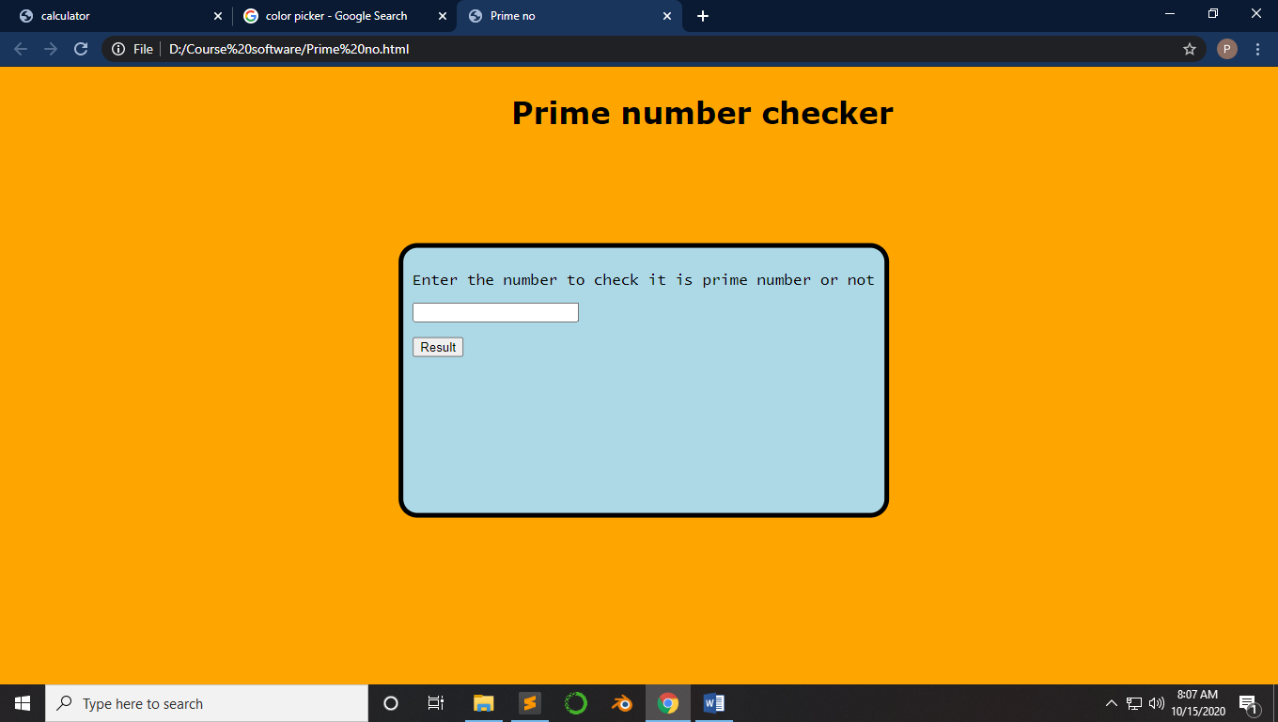

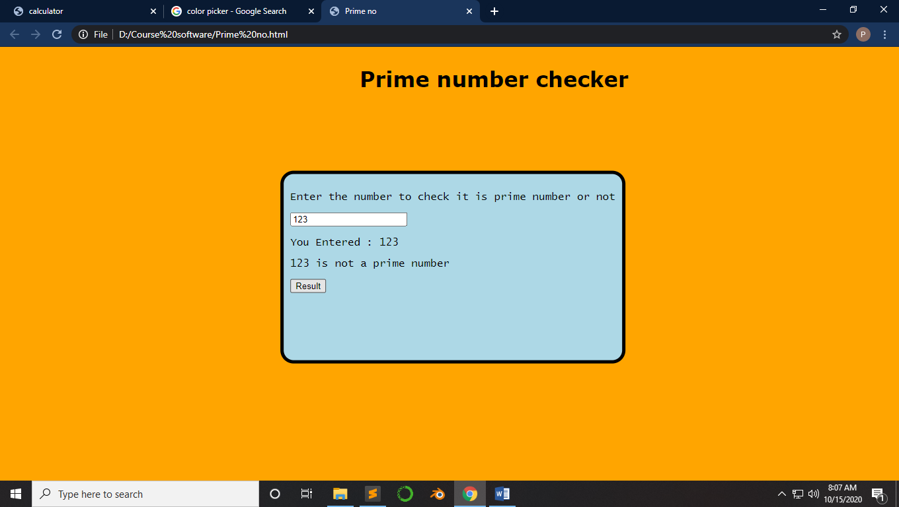

**PRACTICAL NO:-9**

Q1.Write a program to explain all outputs methods of javascript.

Code:-

<!DOCTYPE html>

<html>

<head>

<meta charset="UTF-8">

<meta name="viewport" content="width=device-width, initial-scale=1.0">

<title>Various output</title>

</head>

<style>

body{

background-color: orange;

}

h1{

font-family: Consolas;

margin: 5px;

padding: 5px;

position: absolute;

left: 40%;

}

p{

font-family:Comic Sans MS ;

position: absolute;

left: 40%;

top: 80px;

}

#Ex1{

position: absolute;

top: 150px;

left: 50%;

transform: translateX(-50%)translateY(-50%);

}

#Ex2{

position: absolute;

top: 190px;

left: 50%;

transform: translateX(-50%)translateY(-50%);

}

#Ex3{

position: absolute;

top: 230px;

left: 50%;

transform: translateX(-50%)translateY(-50%);

}

#Ex4{

position: absolute;

top: 270px;

left: 50%;

transform: translateX(-50%)translateY(-50%);

}

</style>

<body>

<h1><em>Welcome to the webpage</em></h1>

<p><big>Try java Code outputs</big></p>

<div id="Container">

<div id="Ex1">

<p id="demo"></p>

<button type="button" onclick="ex1();">Inner html</button>

<script>

function ex1()

{

document.getElementById("demo").innerHTML = 5 + 6;

}

</script>

</div>

<div id="Ex2">

<button type="button" onclick="ex2();">Write</button>

<script>

function ex2()

{

document.write(5 * 6);

}

</script>

</div>

<div id="Ex3">

<button type="button" onclick="ex3();">Alert</button>

<script>

function ex3()

{

window.alert(5 - 6);

}

</script>

</div>

<div id="Ex4">

<button type="button" onclick="ex4();">Print</button>

<script>

function ex4()

{

window.print();

}

</script>

</div>

</div>

</body>

</html>

Output:-

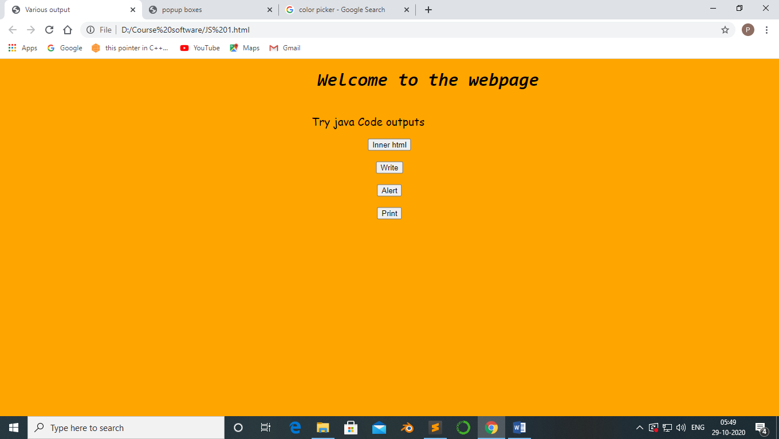

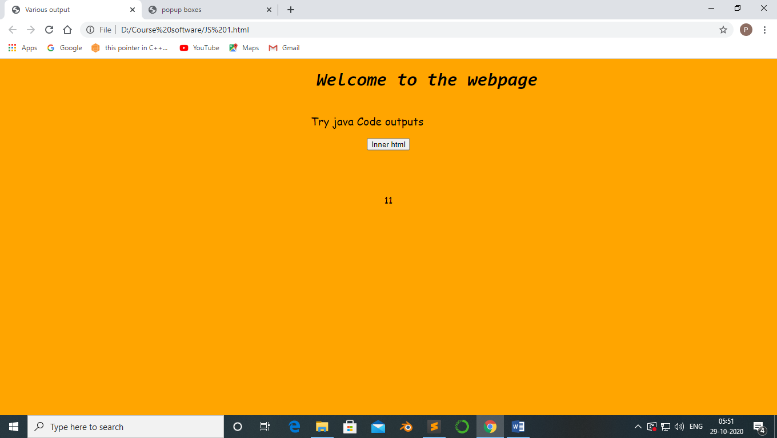

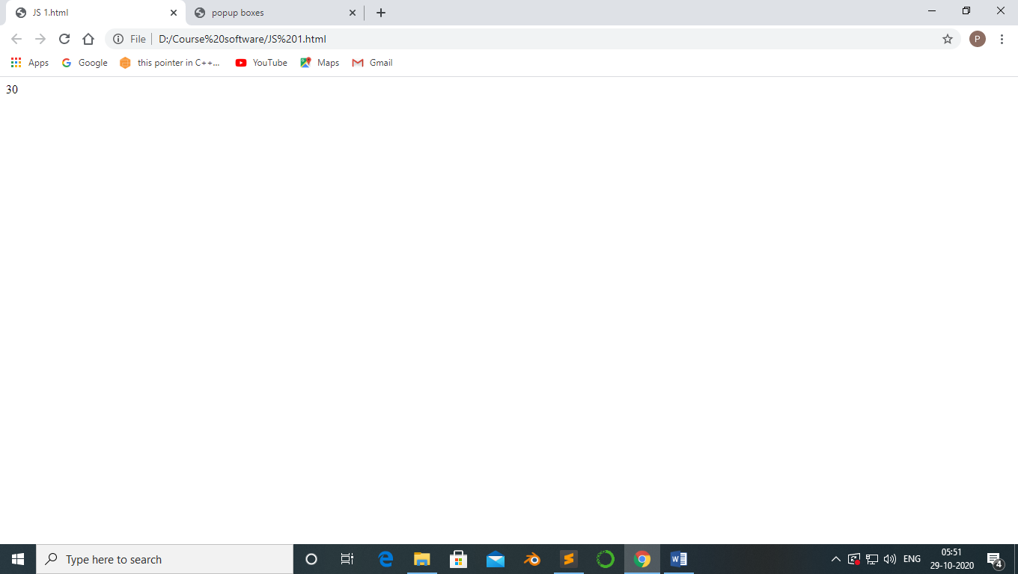

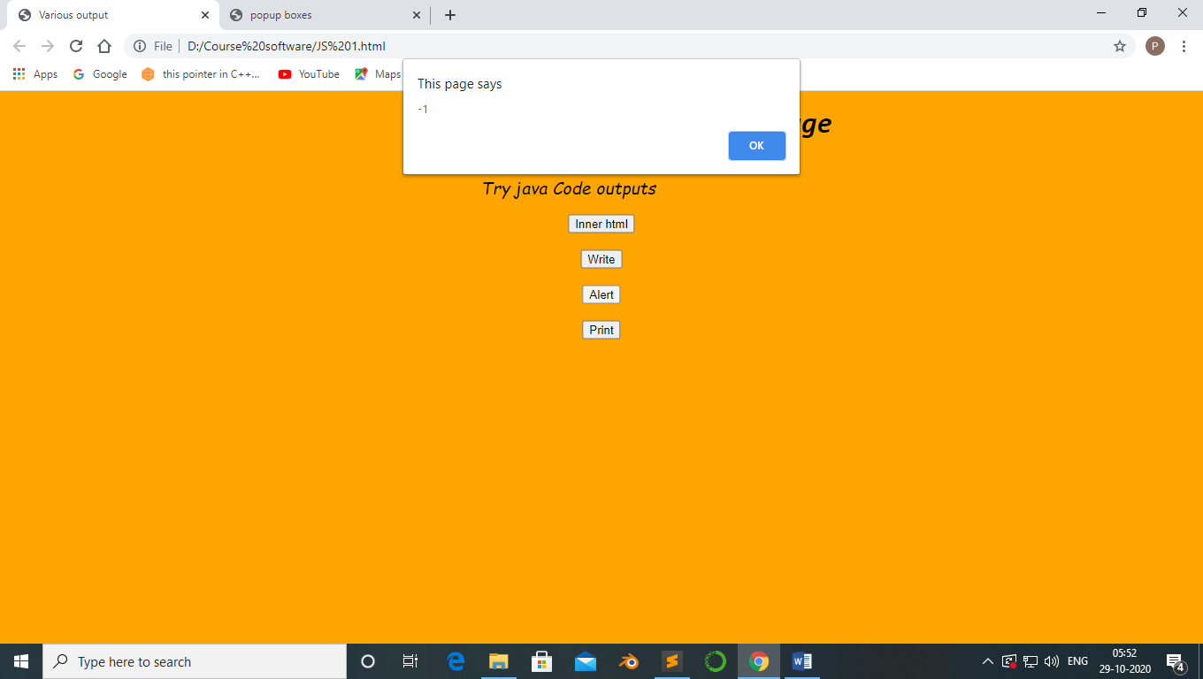

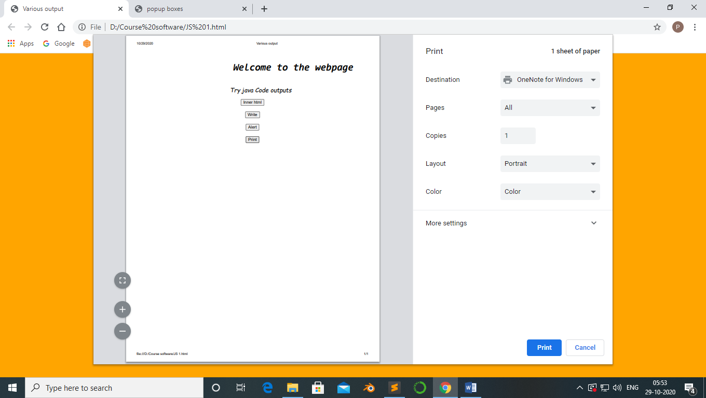

Q2.Write a program to explain javascript pop-up boxes.

Code:-

<!DOCTYPE html>

<html>

<head>

<meta charset="UTF-8">

<meta name="viewport" content="width=device-width, initial-scale=1.0">

<title>popup boxes</title>

</head>

<style>

body{

background-color:#00ad76;

}

h1{

font-family: Consolas;

margin: 5px;

padding: 5px;

position: absolute;

}

#myFunction{

position: absolute;

top: 150px;

left: 30%;

transform: translateX(-50%)translateY(-50%);

}

#Prompt{

position: absolute;

top: 200px;

left: 30%;

transform: translateX(-50%)translateY(-50%);

}

#confirmUser{

position: absolute;

top: 270px;

left: 30%;

transform: translateX(-50%)translateY(-50%);

}

</style>

<body>

<h1>JavaScript Pop-up boxes:-</h1>

<div id="myFunction">

<button onclick="myFunction()">Try alert</button>

</div>

<script>

function myFunction() {

alert(" Alert box warning!");

}

</script>

<div id="confirmUser">

<button onclick="confirmUser();">Try confirm</button>

<p id="sol"></p>

</div>

<script>

function confirmUser() {

var text;

if (confirm("Press a button!")) {

text = "You pressed OK!";

} else {

text = "You pressed Cancel!";

}

document.getElementById("sol").innerHTML = text;

}

</script>

<div id="Prompt">

<button onclick="promptUser();">Try prompt</button>

<p id="result"></p>

</div>

<script>

function promptUser(){

var txt;

var userinput=prompt("Say your name");

if (userinput != null){

txt = "Hello " +userinput + "!!";

}

else {

txt = "User cancelled the prompt.";

}

document.getElementById("result").innerHTML = txt;

}

</script>

</body>

</html>

Output:-

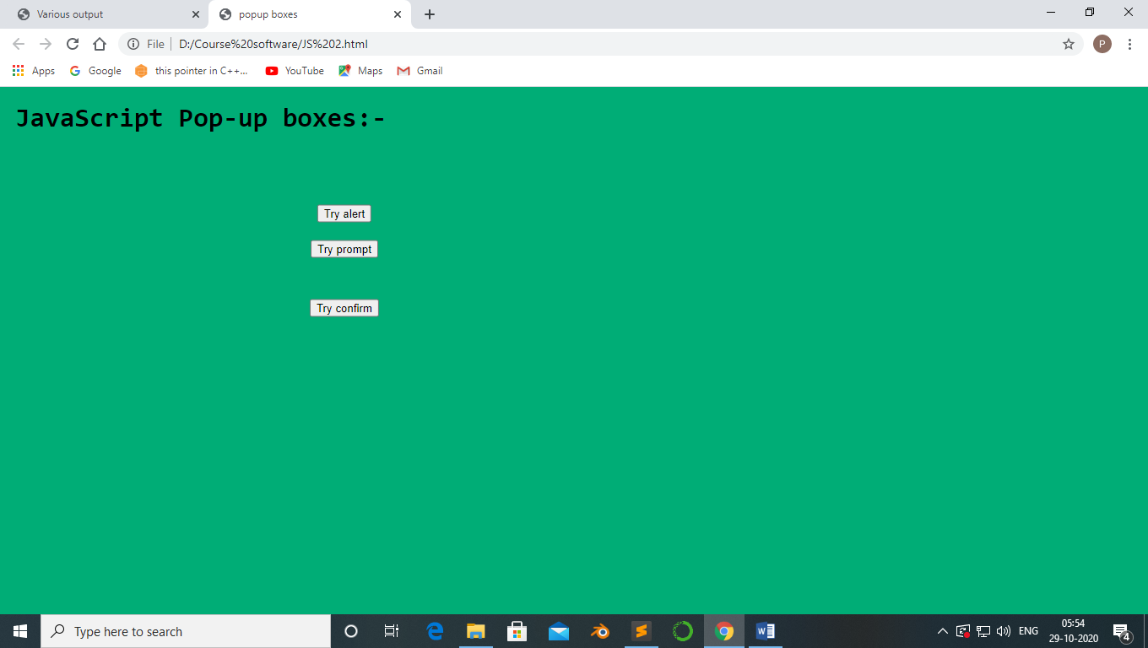

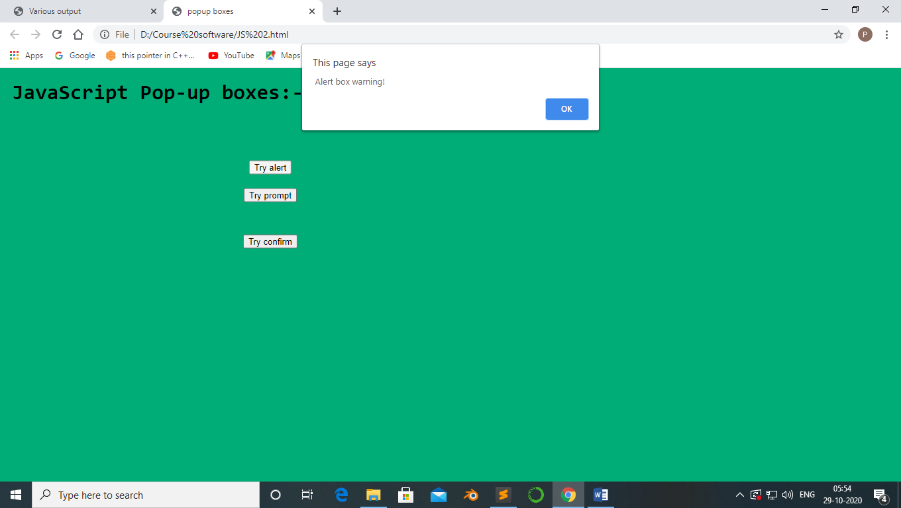

Prompt box:-

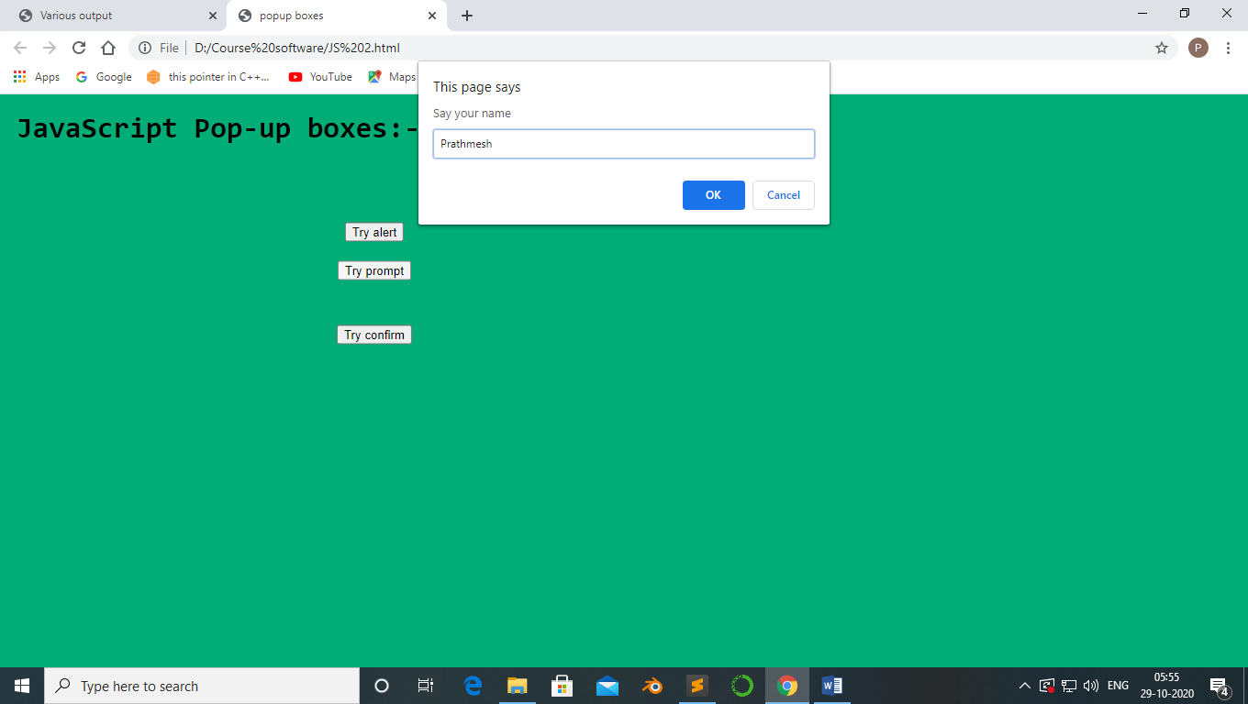

Confirm box:-

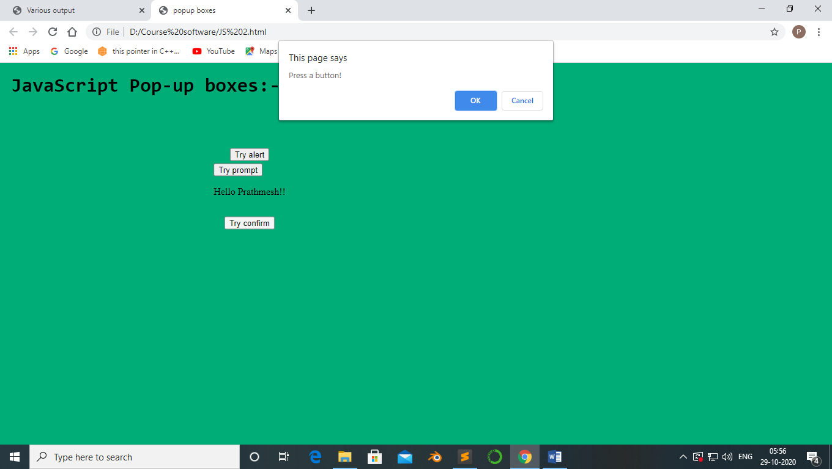

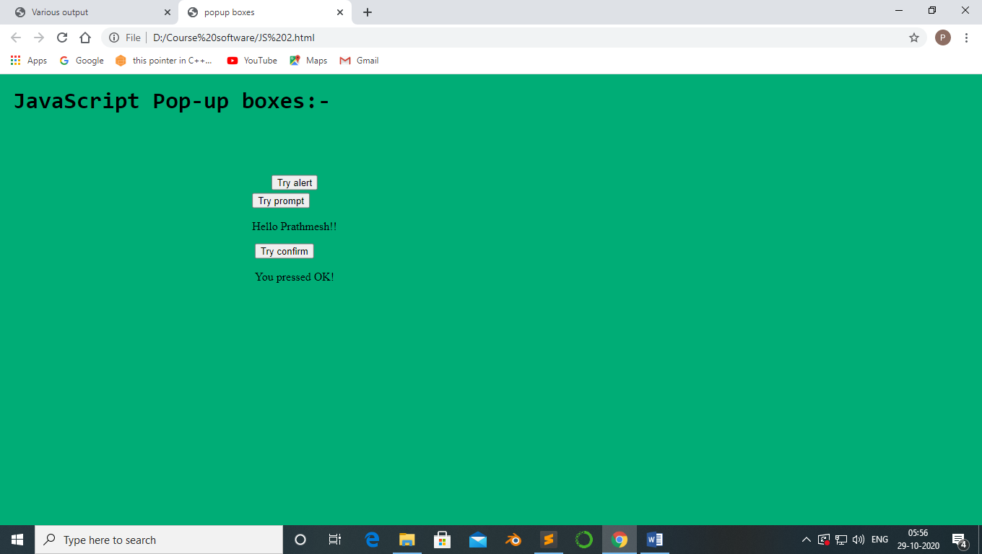

Q3.Write a program explain queryselector and queryselectorAll by taking nesting of elements.

Code:-

<!DOCTYPE html>

<html>

<head>

<meta charset="UTF-8">

<meta name="viewport" content="width=device-width, initial-scale=1.0">

<title>Query selector</title>

</head>

<style >

body{

background-color: steelblue;

}

</style>

<body>

<div id="js00">

<h2 class="example">This is queryselector example</h2>

<p class="example">This is Prathmesh Patil.</p>

<button onclick="myFunction()">Try it</button>

<script>

function myFunction() {

document.querySelector(".example").style.backgroundColor = "red";

}

</script>

<div id="js01">

<h2 class="example">This is queryselectorall example</h2>

<p class="example">This is Prathmesh patil.</p>

<button onclick="select1()">Try it</button>

<script>

function select1() {

var x, i;

x = document.querySelectorAll(".example");

for (i = 0; i < x.length; i++) {

x[i].style.backgroundColor = "orange";

}

}

</script>

</div>

</body>

</html>

Output:-

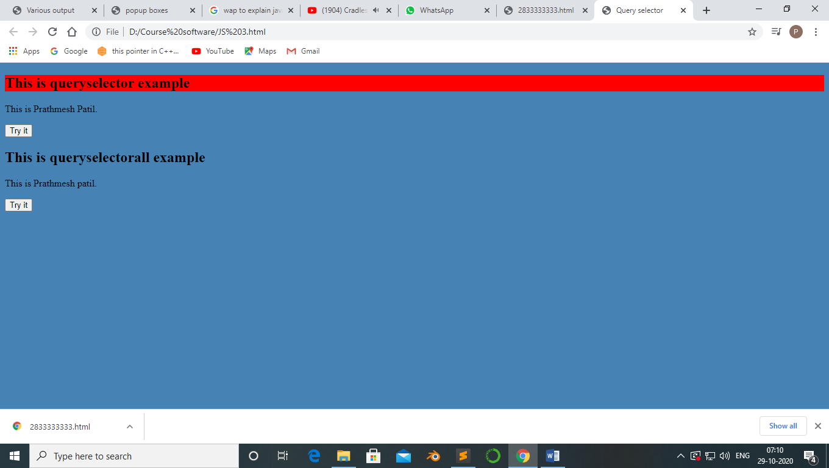

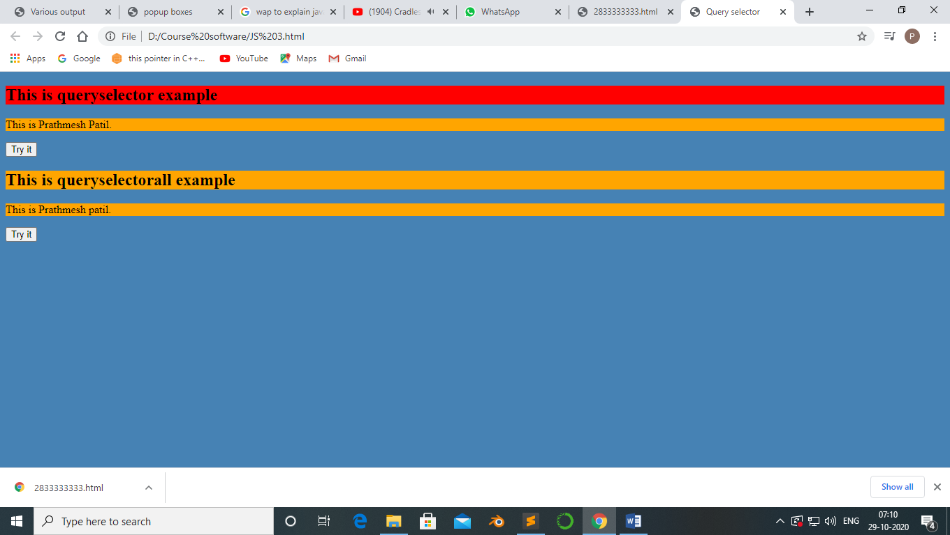

**PRACTICAL NO:-10**

Q Write a program for form validation using regular expression for

1. Phone number.
2. Email.
3. Password.

Code:-

<!DOCTYPE html>

<html>

<head>

<title>JavaScript Form Validation</title>

<style>

body{

margin: 0px;

padding: 0px;

background-color:black ;

}

#container{

position: absolute;

top: 250px;

left: 50%;

transform: translateX(-50%)translateY(-50%);

border: 2px solid black;

border-radius: 3px;

border-color:blue;

}

form{

margin:auto;

padding:50px;

width:300px;

text-align:left;

background-color:red;

color:white;

font-family: Unispace;

font-size: 90%;

}

</style>

</head>

<body>

<div id="container">

<form onsubmit="validate()">

<p>

<label for="Phone Number">Phone Number:-</label>

<input type="text"id="phone-number" placeholder="Enter your phone number"/>

</p>

<p>

<label for="Email-address">Email-address:-</label>

<input type="text"id="email" placeholder="Enter your email"/>

</p>

<p>

<label for="Password">Password:-</label>

<input type="password"id="password" placeholder="Enter your password"/>

</p>

<p>

<input type="submit" />

</p>

</form>

<script>

function validate(){

var phoneNumber = document.getElementById('phone-number').value;

var email = document.getElementById('email').value;

var password = document.getElementById('password').value;

var phoneRGEX = /^[(]{0,1}[0-9]{3}[)]{0,1}[-\s\.]{0,1}[0-9]{3}[-\s\.]{0,1}[0-9]{4}$/;

var emailRGEX = /^[a-zA-Z0-9.!#$%&'*+/=?^_`{|}~-]+@[a-zA-Z0-9-]+(?:\.[a-zA-Z0-9-]+)*$/;

var passwordRGEX = /^(?=.*\d)(?=.*[a-z])(?=.*[A-Z])(?=.*[^a-zA-Z0-9])(?!.*\s).{8,15}$/;

var phoneResult = phoneRGEX.test(phoneNumber);

var emailResult = emailRGEX.test(email);

var passwordResult = passwordRGEX.test(password);

if(phoneResult == false)

{

window.alert('Please enter a valid phone number');

return false;

}

if(emailResult == false)

{

window.alert('Please enter a valid Email address');

return false;

}

if(passwordResult == false)

{

window.alert('Please enter a valid Password');

return false;

}

else

{

window.alert('Thank you!');

return true;

}

}

</script>

</div>

</body>

</html>

Output:-

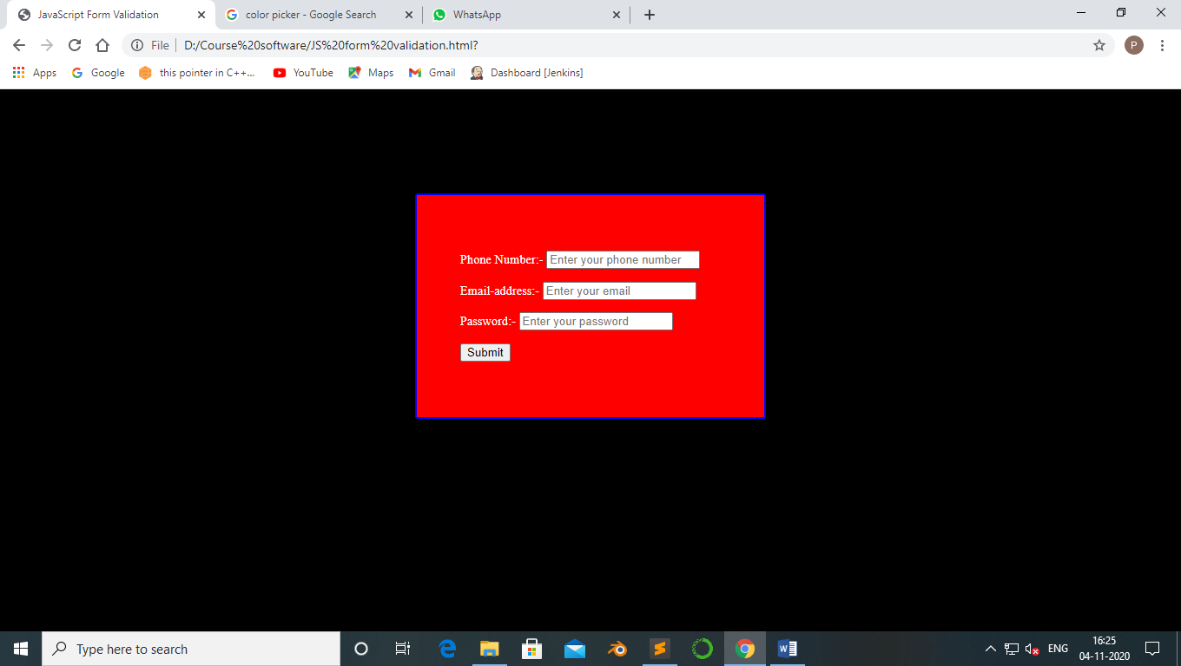

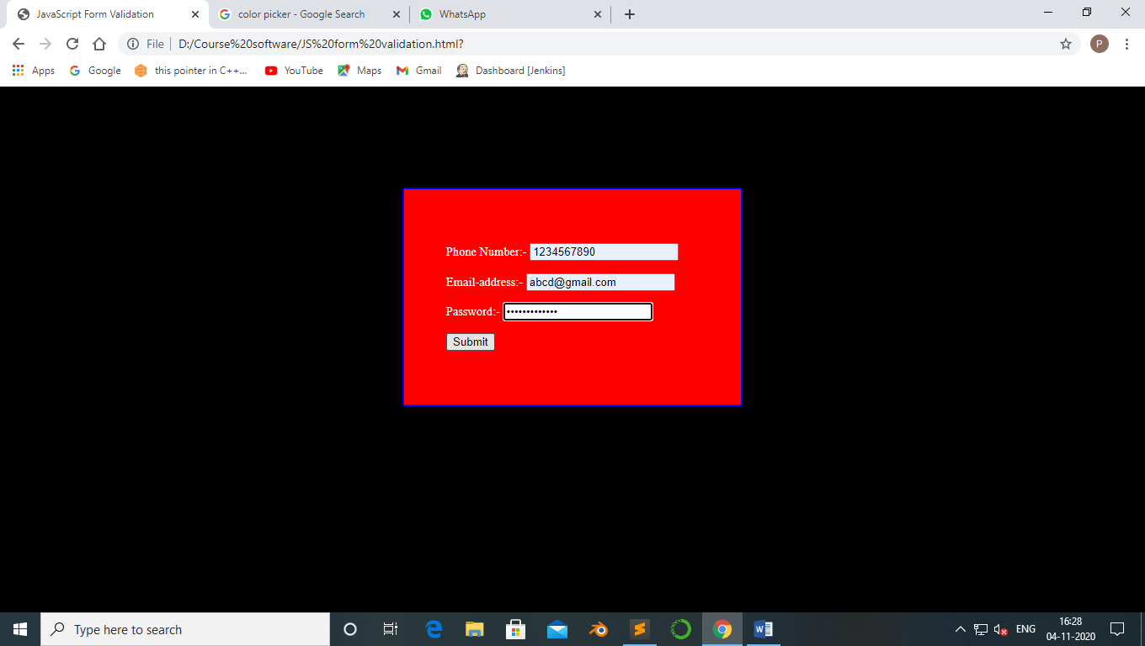

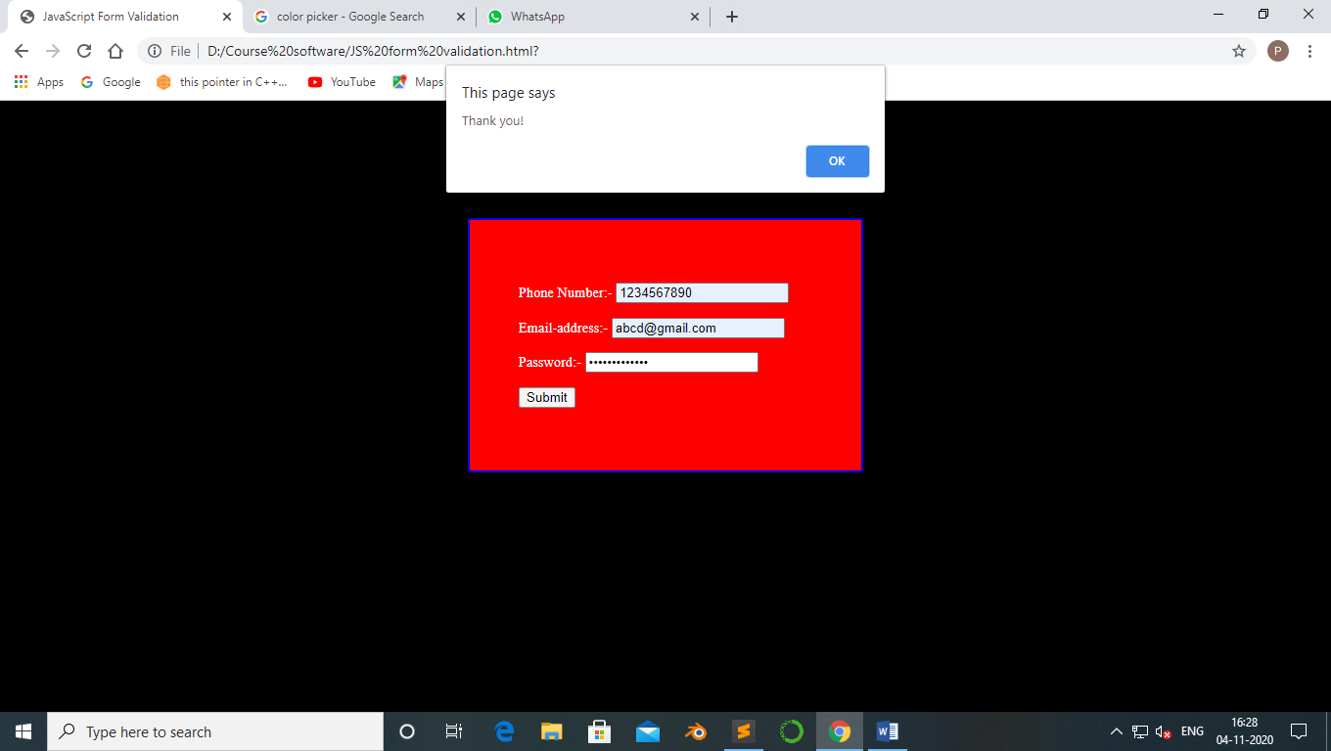

**PRACTICAL NO :-11**

1. Write an XML to show library books database.

Code:-

<?xml version="1.0" encoding="UTF-8"?>

<library>

<books>

<name>Karmayoddha Granth</name>

<price>rs 500</price>

<authors>Amit Shah</authors>

</books>

<books>

<name>The Bloomsbury Anthology of Great Indian Poems</name>

<price>rs 500</price>

<authors>Abhay K.</authors>

</books>

<books>

<name>Celestial Bodies</name>

<price>rs 500</price>

<authors>Jokha Alharthi</authors>

</books>

<books>

<name>The Braille edition of the book Exam Warriors</name>

<price>rs 500</price>

<authors>PM Narendra Modi</authors>

</books>

</library>

Output:-

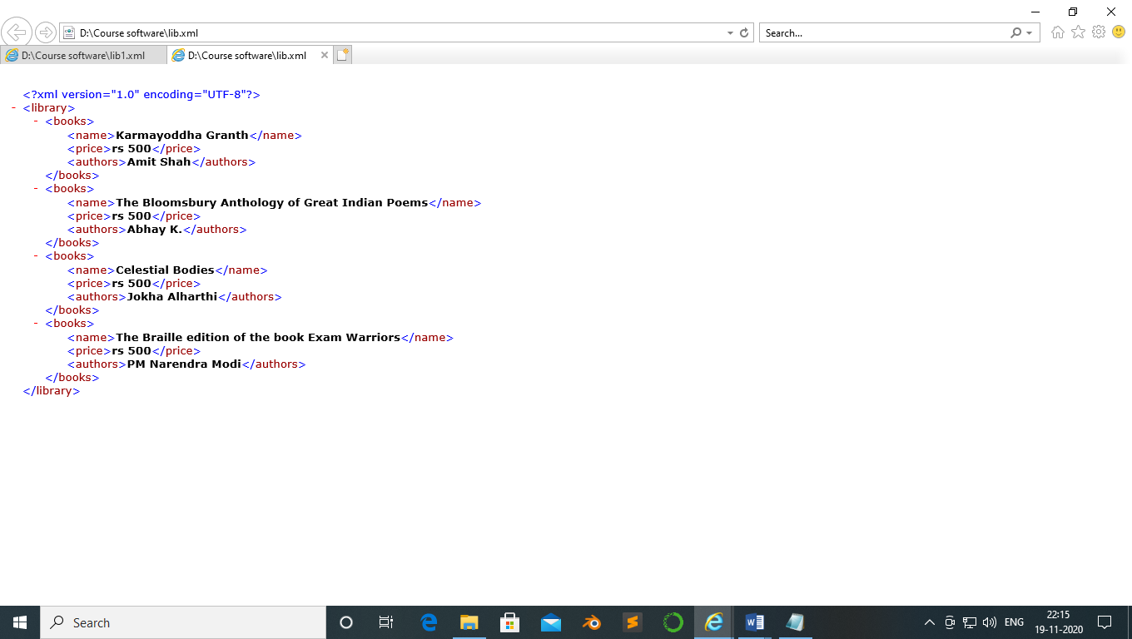

2. Write an XSL code to display XML transformation to XSLT (take above XML of library.

**XML Code:-**

<?xml version="1.0" encoding="UTF-8"?>

<?xml-stylesheet type="text/xsl" href="lib2.xsl"?>

<library>

<books>

<name>Karmayoddha Granth</name>

<price>Rs 500</price>

<authors>Amit Shah</authors>

</books>

<books>

<name>The Bloomsbury Anthology of Great Indian Poems</name>

<price>Rs 500</price>

<authors>Abhay K.</authors>

</books>

<books>

<name>Celestial Bodies</name>

<price>Rs 500</price>

<authors>Jokha Alharthi</authors>

</books>

<books>

<name>The Braille edition of the book Exam Warriors</name>

<price>Rs 500</price>

<authors>PM Narendra Modi</authors>

</books>

</library>

**XSL Code:-**

<?xml version="1.0" encoding="UTF-8"?>

<xsl:stylesheet xmlns:xsl="http://www.w3.org/1999/XSL/Transform" version="1.0">

<xsl:template match="/">

<html>

<body>

<h2>Library</h2>

<table border="1">

<tr bgcolor="#9acd32">

<th>name</th>

<th>price</th>

<th>authors</th>

</tr>

<xsl:for-each select="library/books">

<tr>

<td><xsl:value-of select="name"/></td>

<td><xsl:value-of select="price"/></td>

<td><xsl:value-of select="authors"/></td>

</tr>

</xsl:for-each>

</table>

</body>

</html>

</xsl:template>

</xsl:stylesheet>

**Output:-**

